Practical 7
1. Aim
To integrate AWS Lambda functions with Amazon DynamoDB and Amazon API Gateway to perform CRUD (Create, Read, Update, and Delete) operations on database records using HTTP requests in the AWS Mumbai region (ap-south-1).
2. Software and services required
- AWS Management Console
- AWS Lambda
- Amazon DynamoDB
- Amazon API Gateway
- AWS IAM (Identity and Access Management)
- Web browser or API testing tool
3. Theory
AWS Lambda is a serverless computing service that executes code in response to events without requiring the user to manage servers.
Amazon DynamoDB is a fully managed NoSQL database service used to store and retrieve data.
Amazon API Gateway is a service that creates HTTP or REST APIs and routes client requests to Lambda functions.
CRUD operations are performed as follows:
Operation | HTTP method | Description
Create | POST | Add a new record
Read | GET | Retrieve a record
Update | PUT | Modify an existing record
Delete | DELETE | Remove a record
The working process is:

Client / Browser / API Tester
↓
Amazon API Gateway
↓
AWS Lambda Function (Python)
↓
Amazon DynamoDB Table
When a client sends an HTTP request, API Gateway invokes Lambda. The Lambda function processes the request and performs the required operation on DynamoDB. Finally, it returns an HTTP response to the client.
4. Procedure
Step 1: Create a DynamoDB table
- Sign in to the AWS Management Console.
- Select the AWS region Asia Pacific (Mumbai) — ap-south-1.
- Open Amazon DynamoDB.

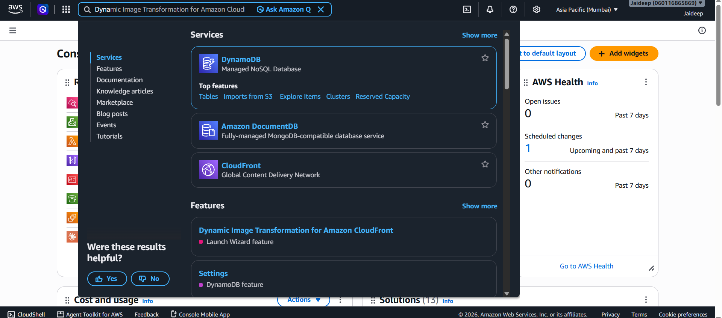
- Select Tables → Create table.

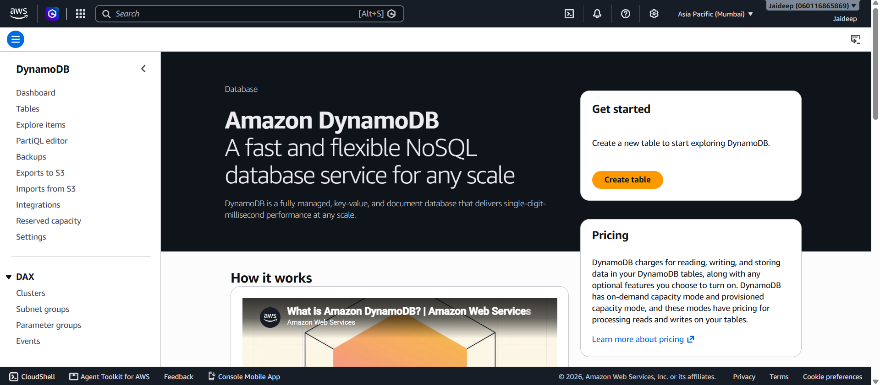
- Enter the following details:
  - Table name: StudentRecords
  - Partition key: studentId
  - Key type: String
  - Leave other settings at their defaults for this basic practical.

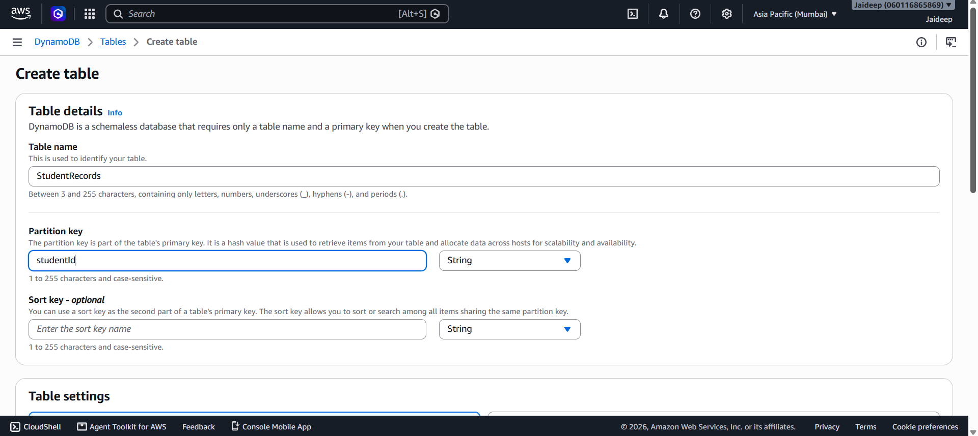
- Click Create table and wait until the table status becomes Active.

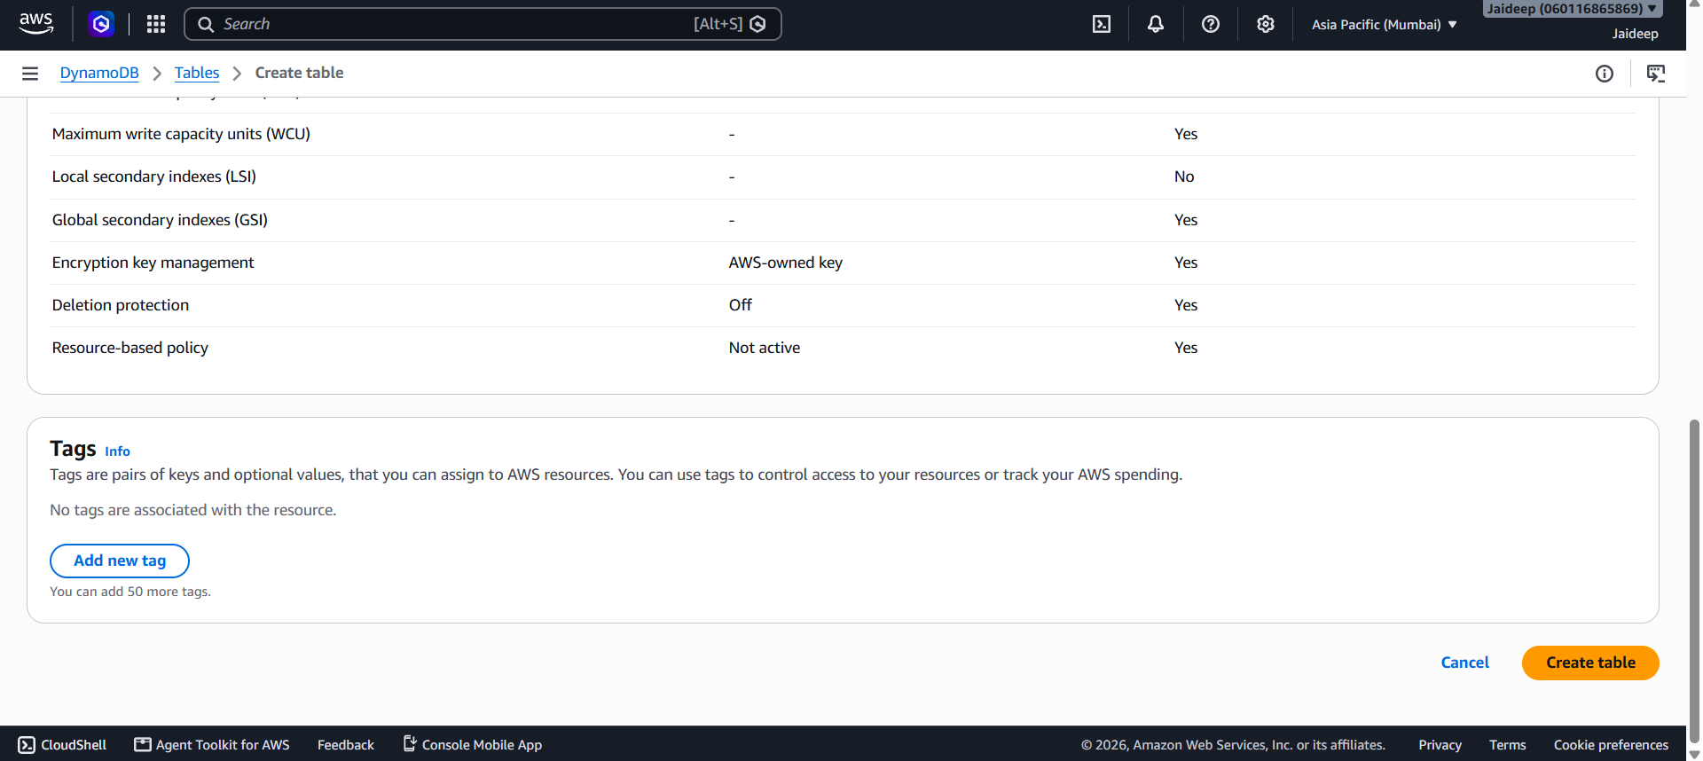

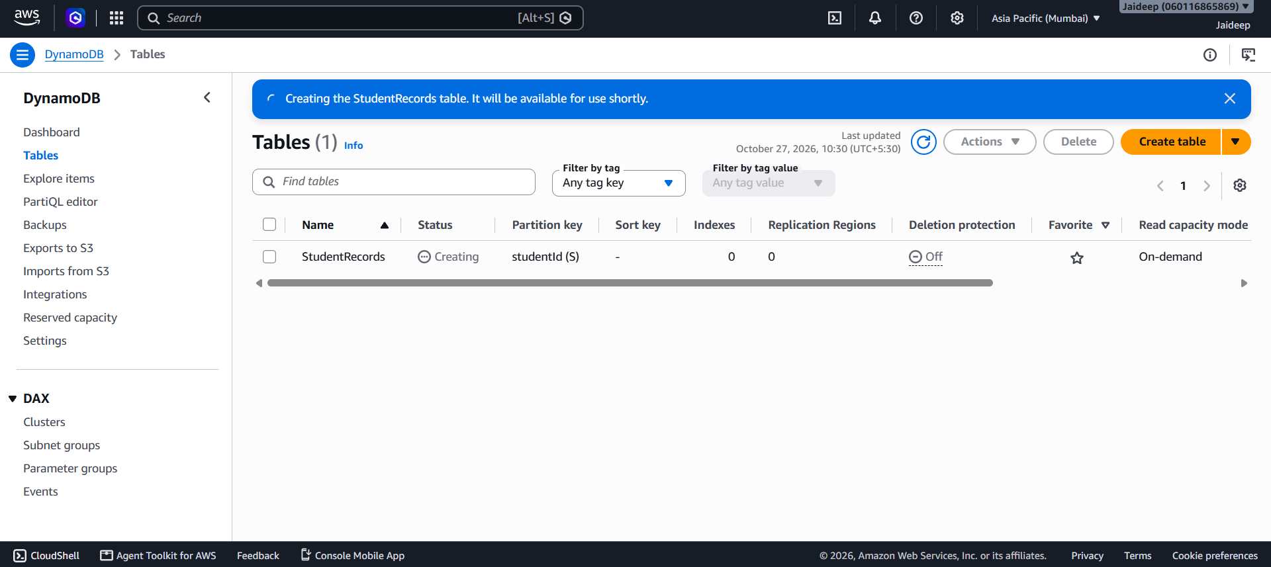

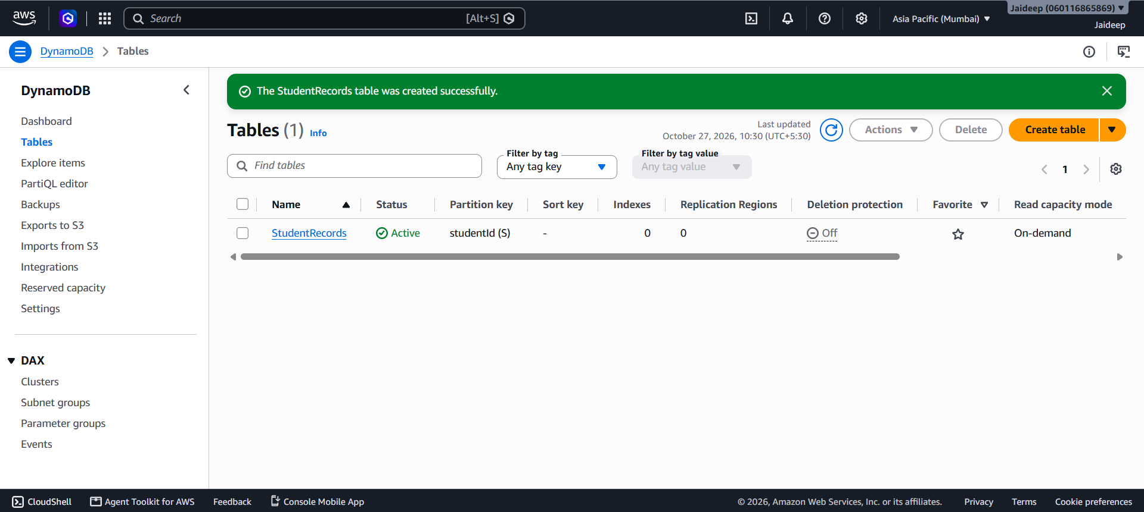
The table will store student records containing a student ID, name, and course.
Step 2: Create an IAM role for Lambda
- Open the IAM service in the AWS Console.

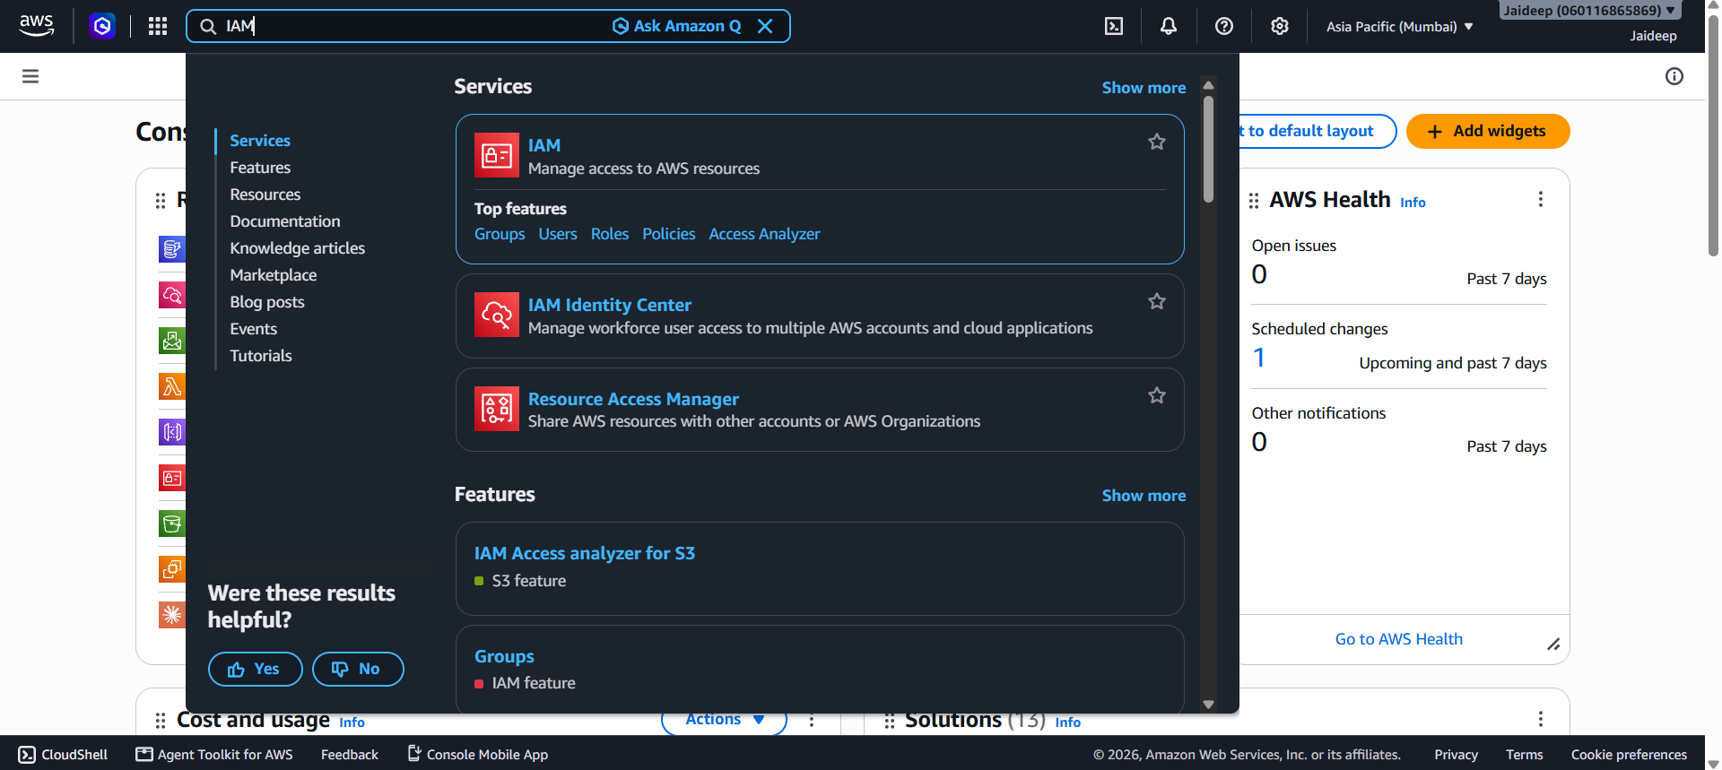
- Select Roles → Create role.

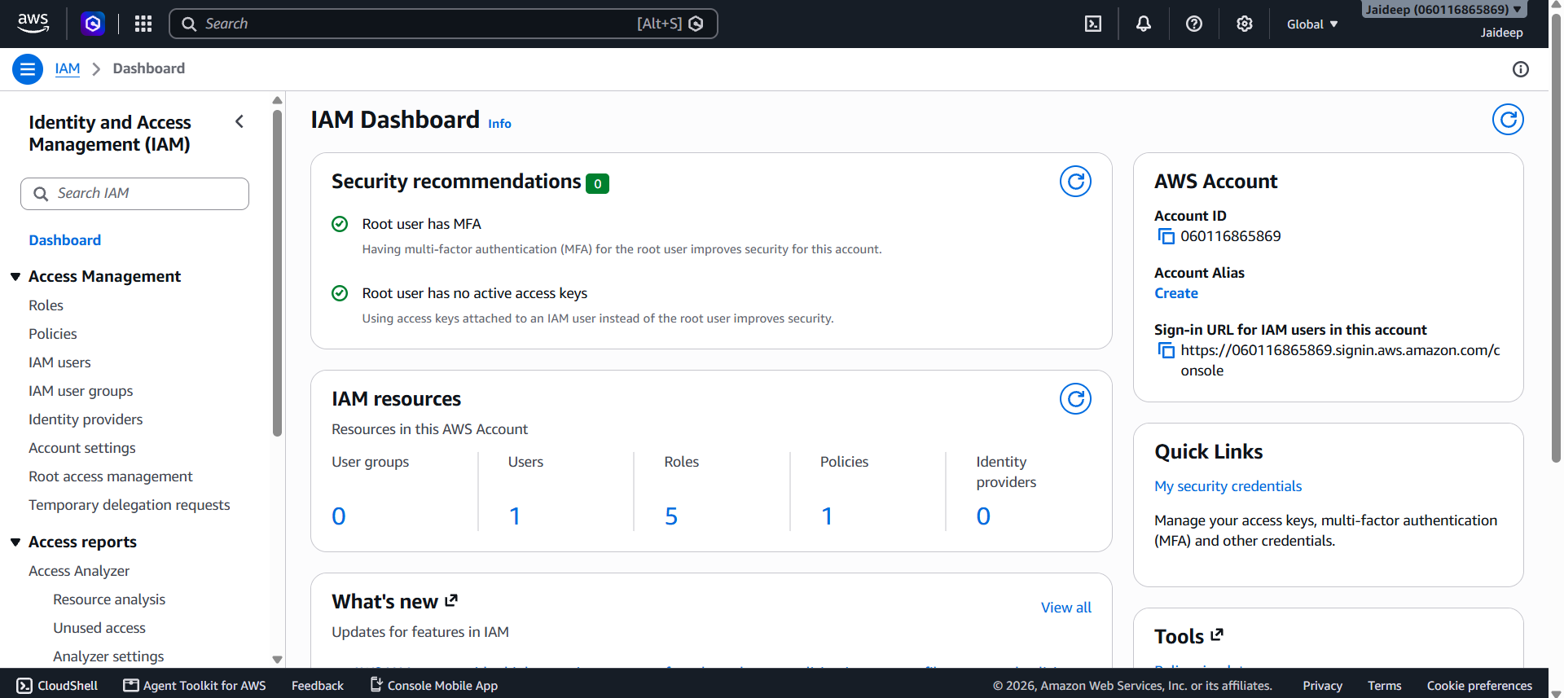

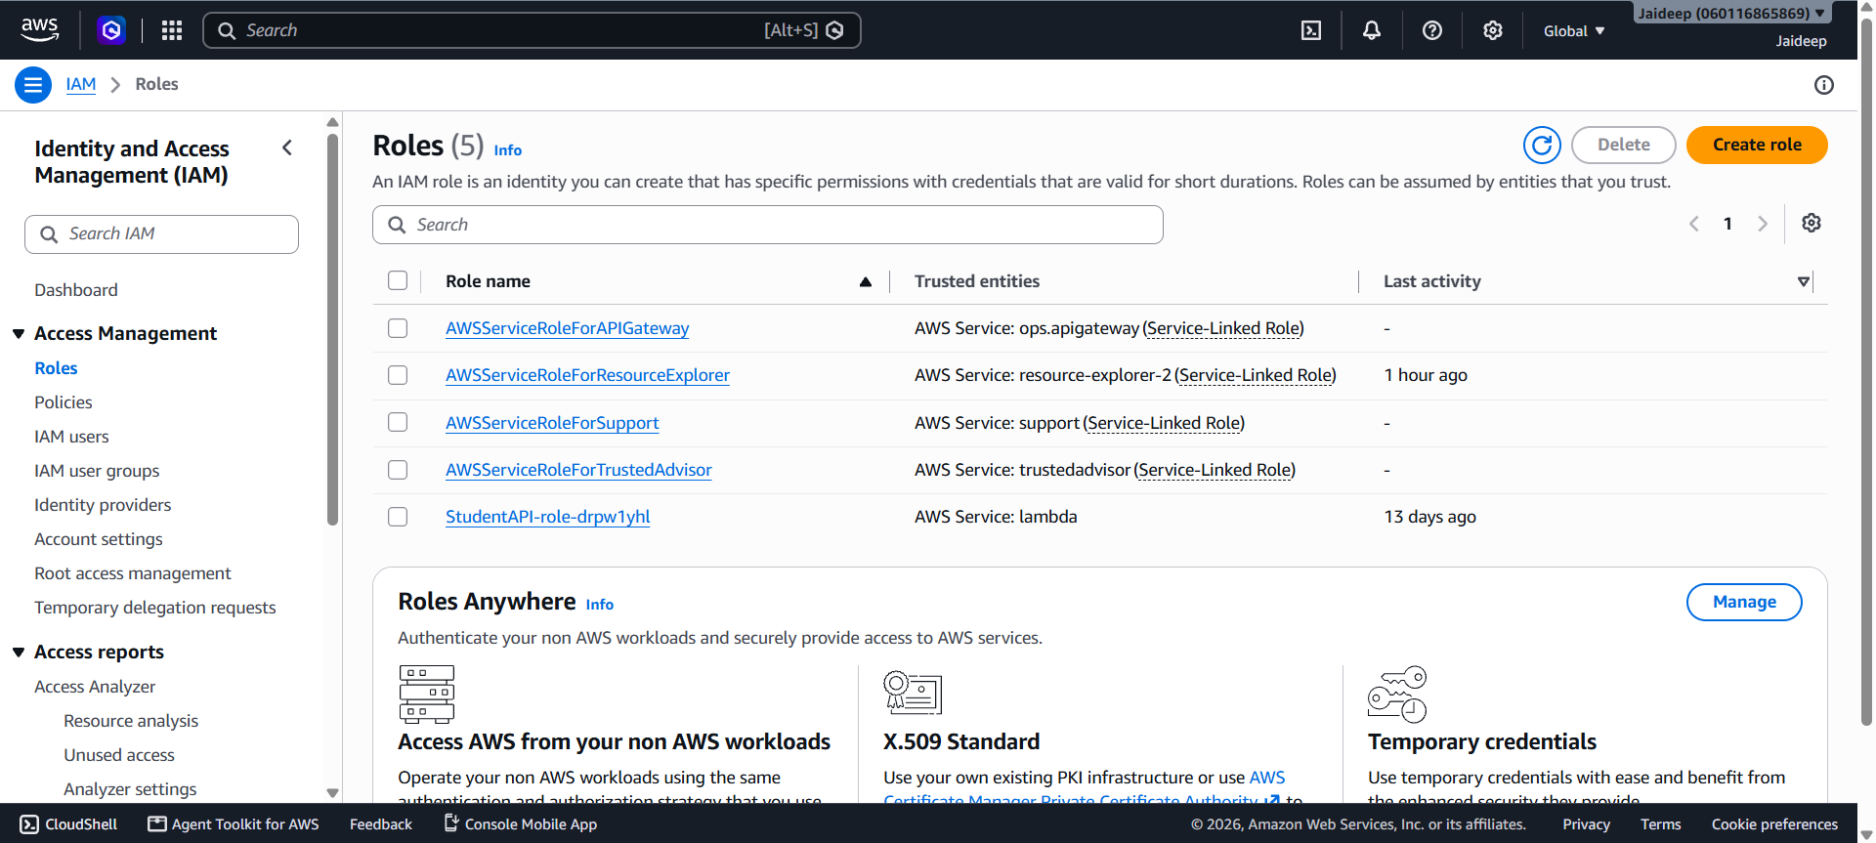
- Choose AWS service as the trusted entity and Lambda as the use case.

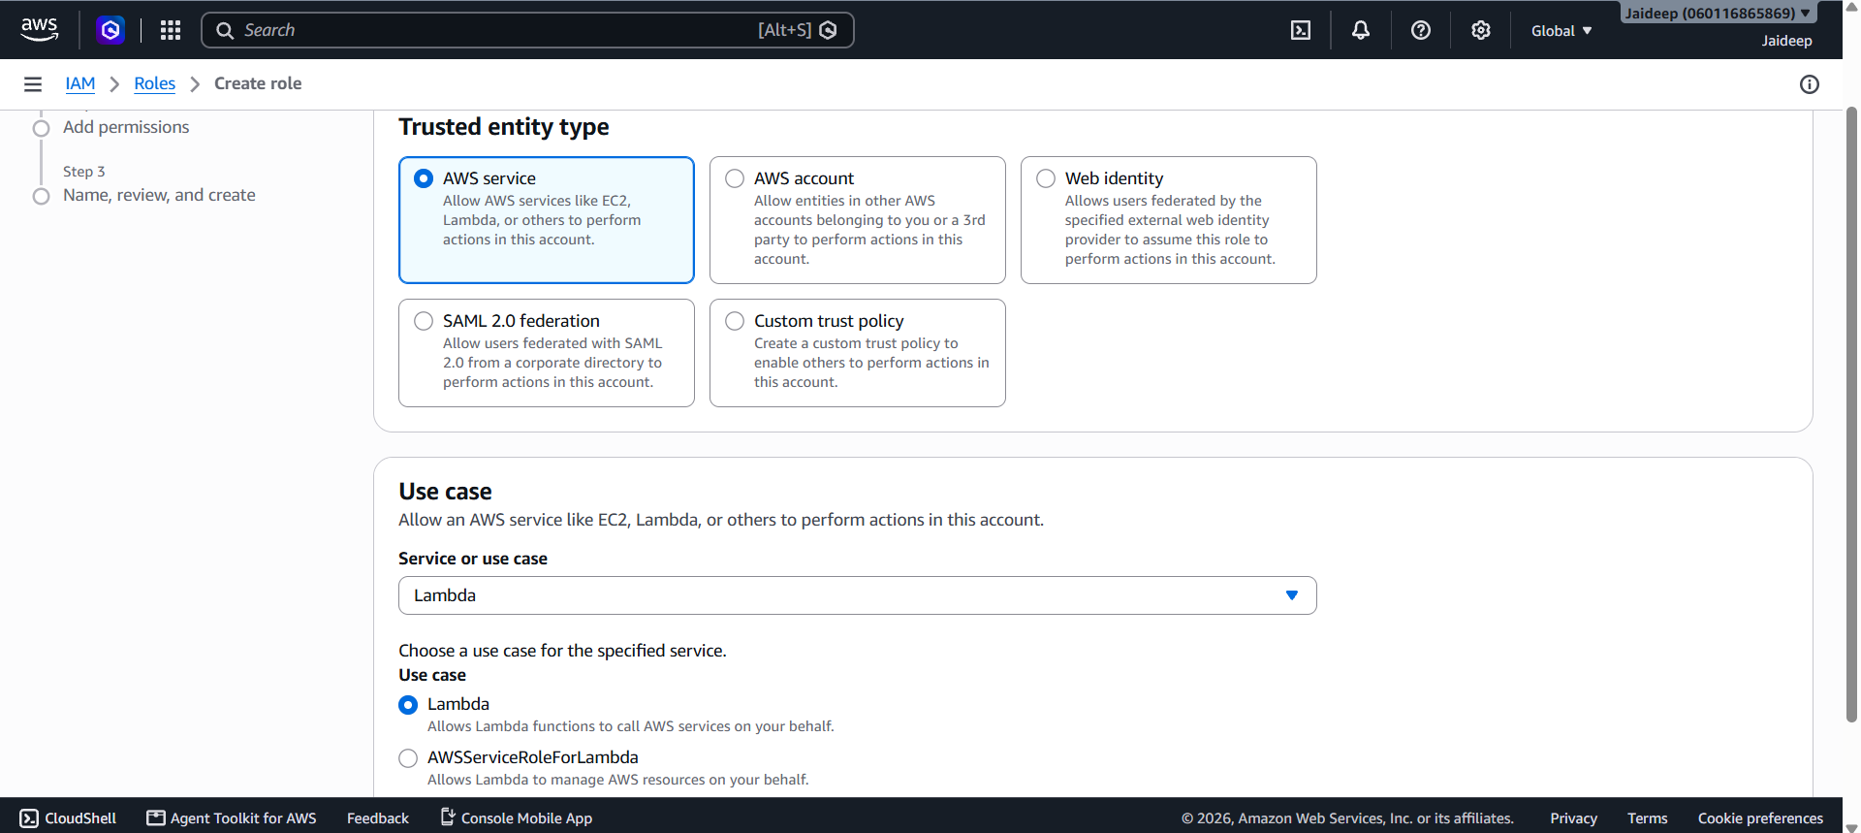
- Attach the basic Lambda logging permission-AWSLambdaBasicExecutionRole. Click Next.

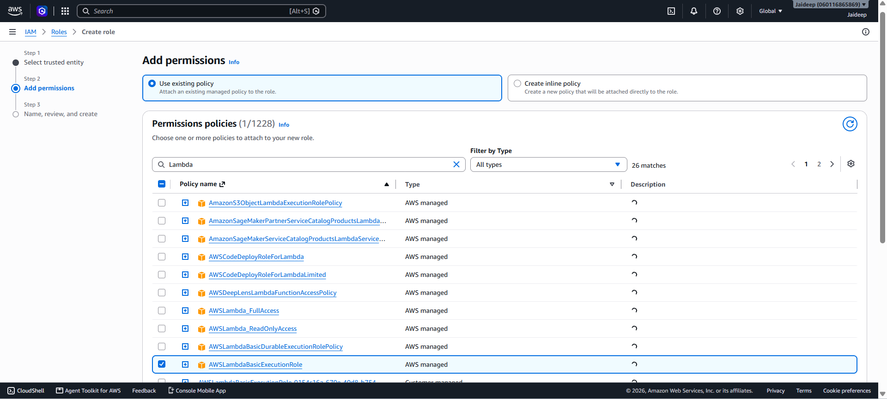

- Create the role with a suitable name, such as LambdaDynamoDBCRUDRole. Click Create Role.

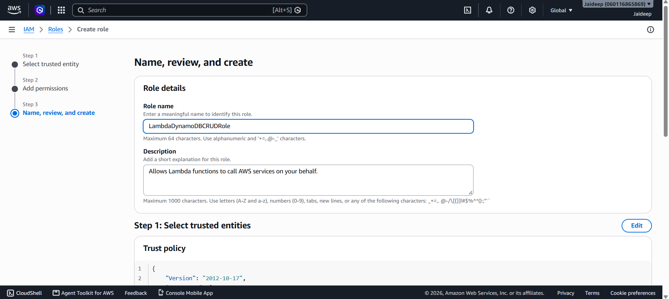

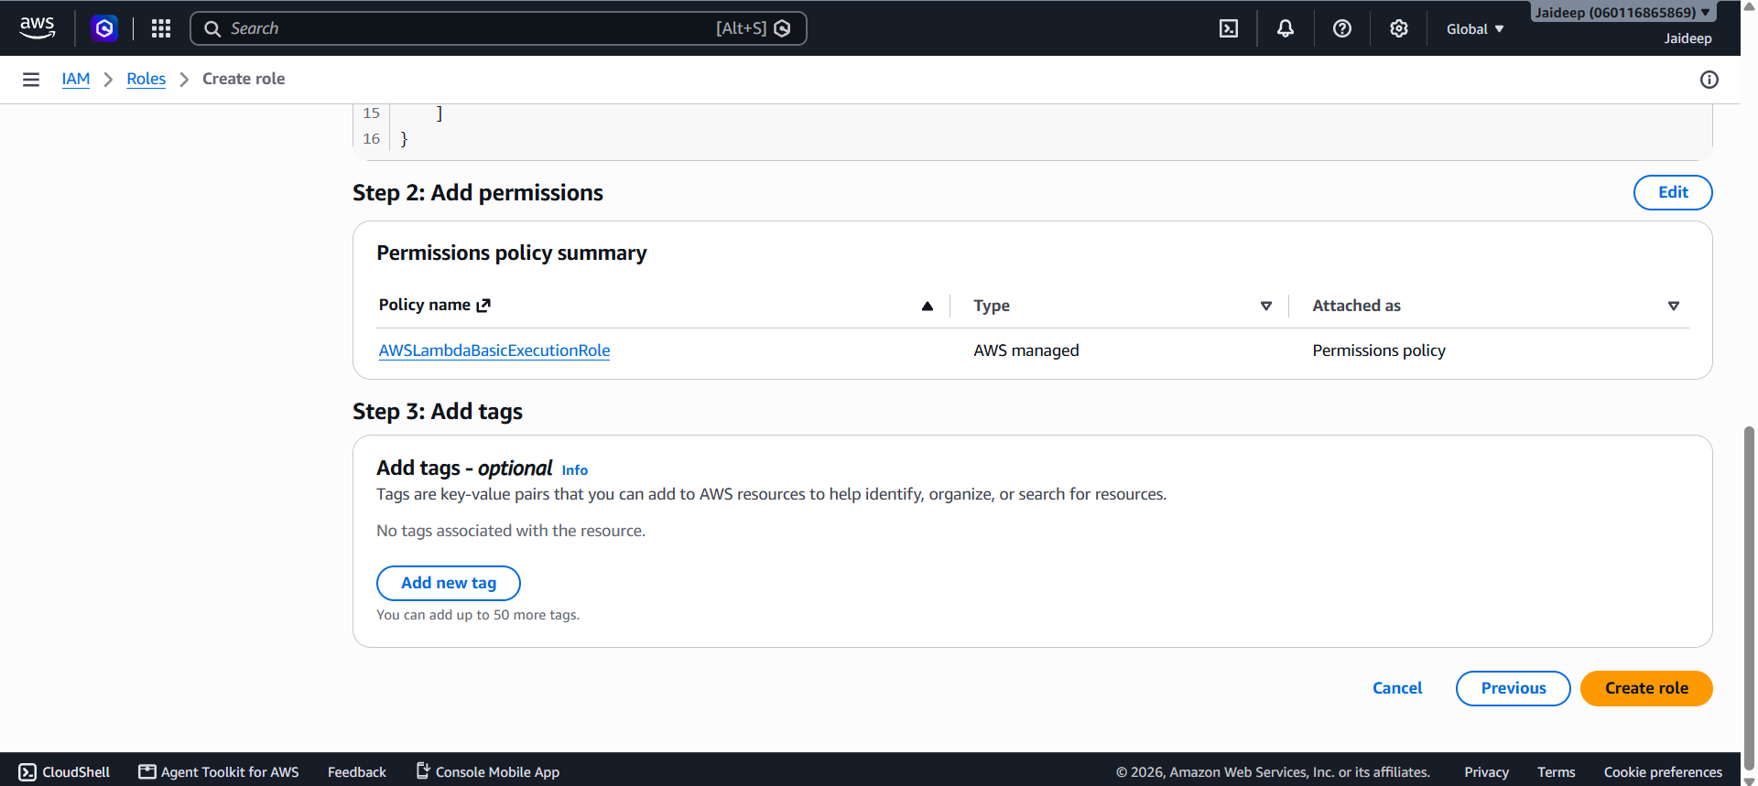

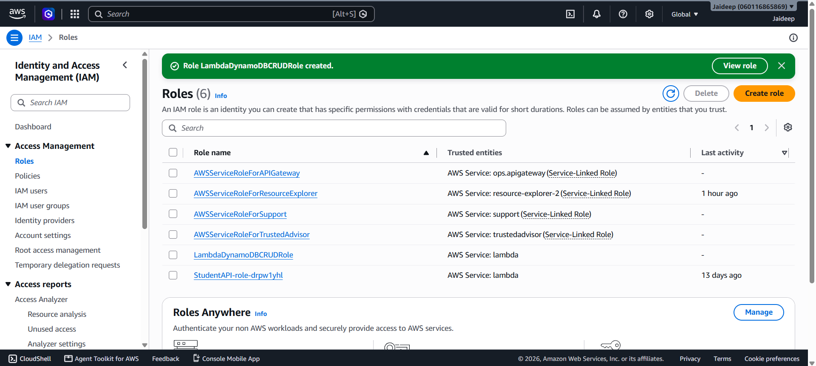
- After the role is created, open IAM → Roles → LambdaDynamoDBCRUDRole.

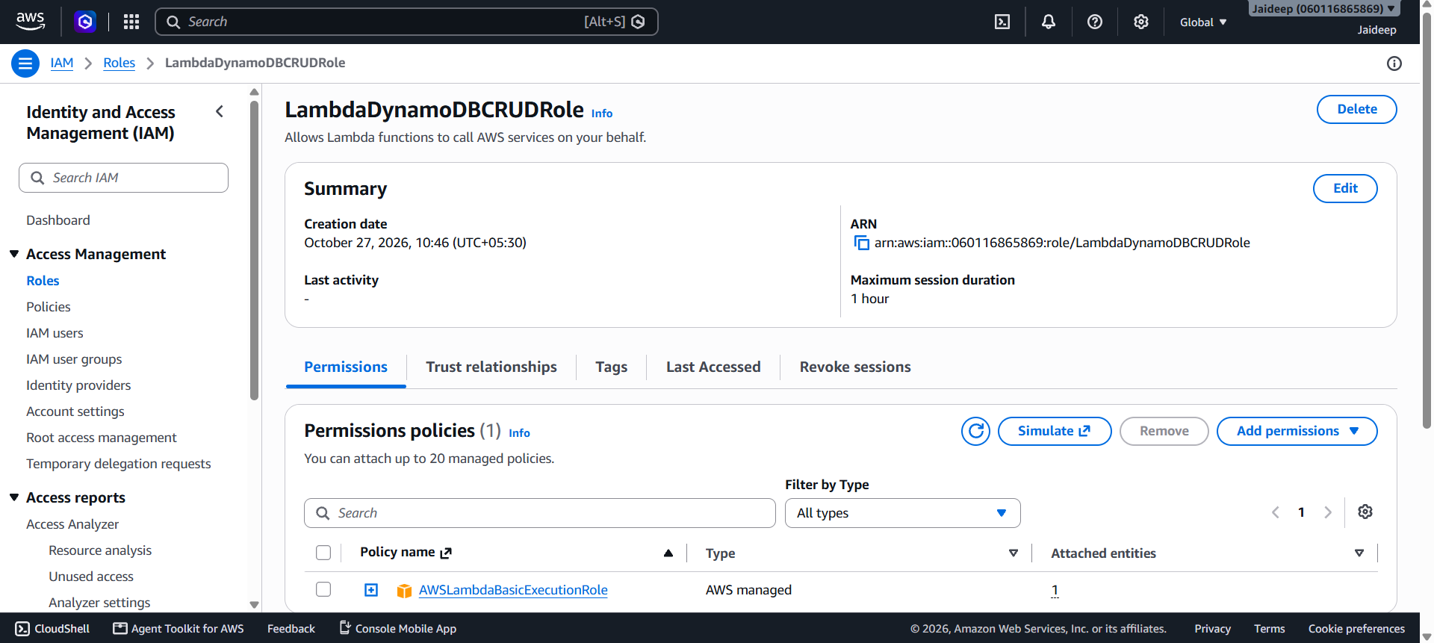
- Select Add permissions → Create inline policy.

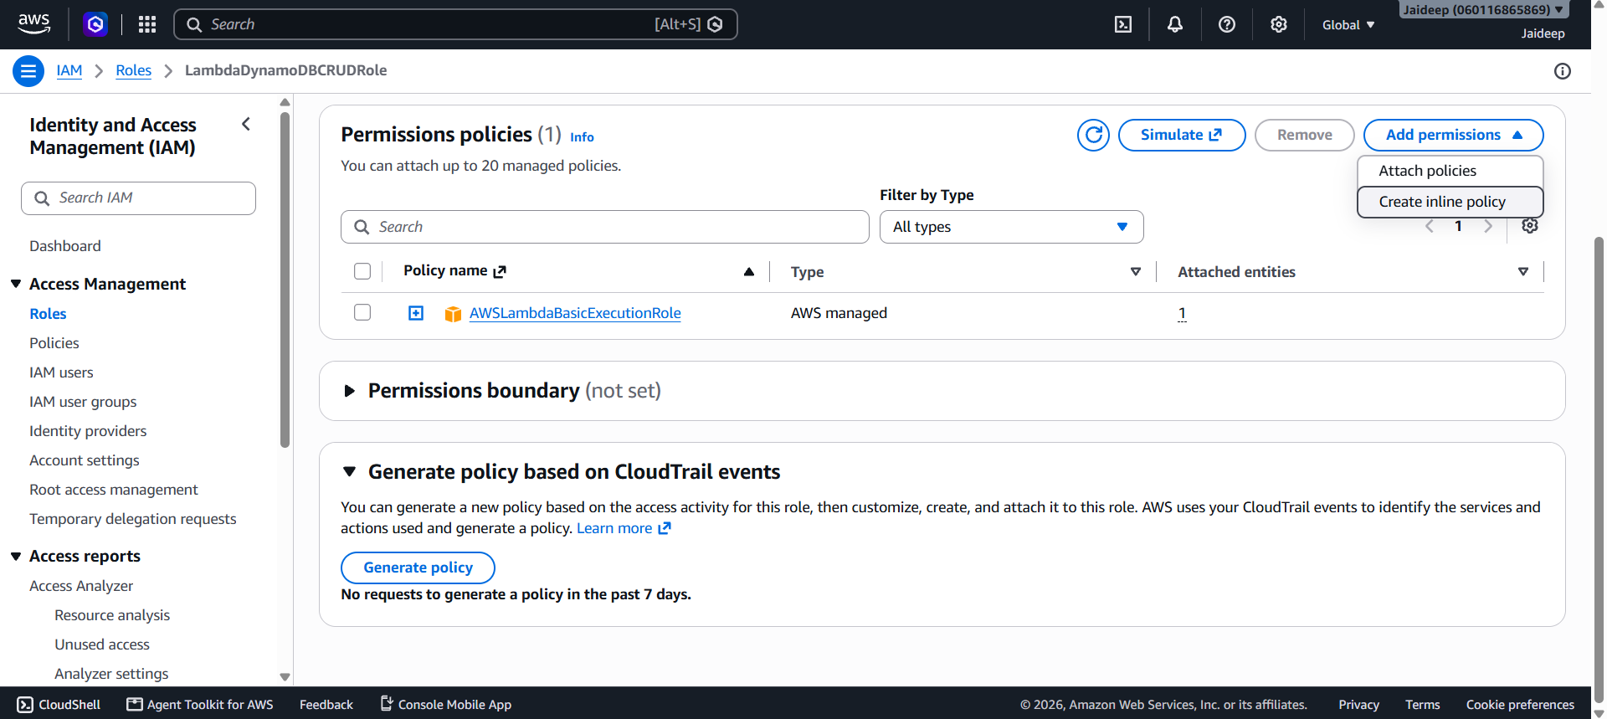
- Choose the JSON editor. Paste this policy:
{
"Version": "2012-10-17",
"Statement": [
{
"Effect": "Allow",
"Action": [
"dynamodb:PutItem",
"dynamodb:GetItem",
"dynamodb:UpdateItem",
"dynamodb:DeleteItem"
],
"Resource": "arn:aws:dynamodb:ap-south-1:YOUR_ACCOUNT_ID:table/StudentRecords"
}
]
}

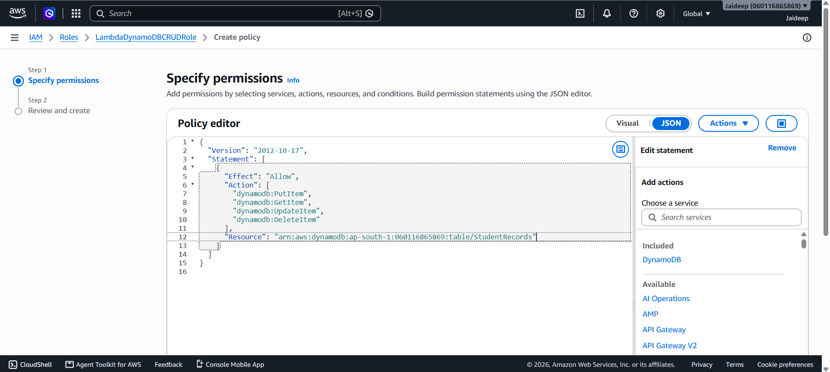
- Save the policy and role.

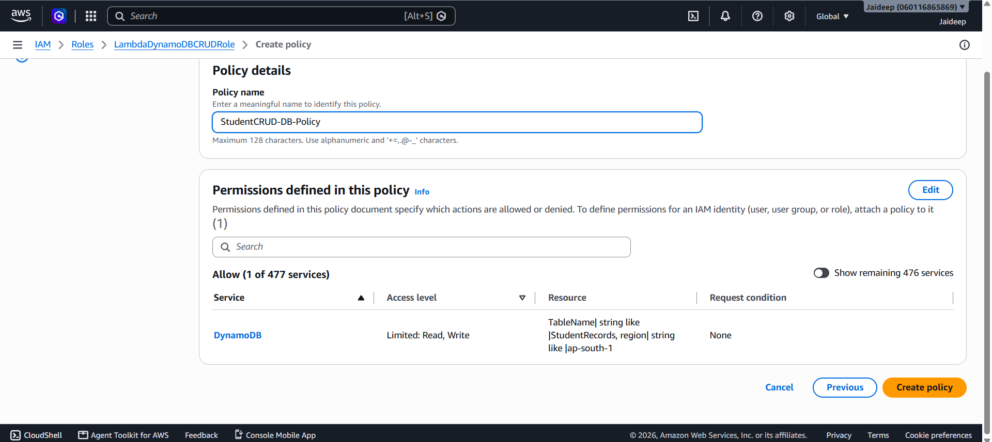

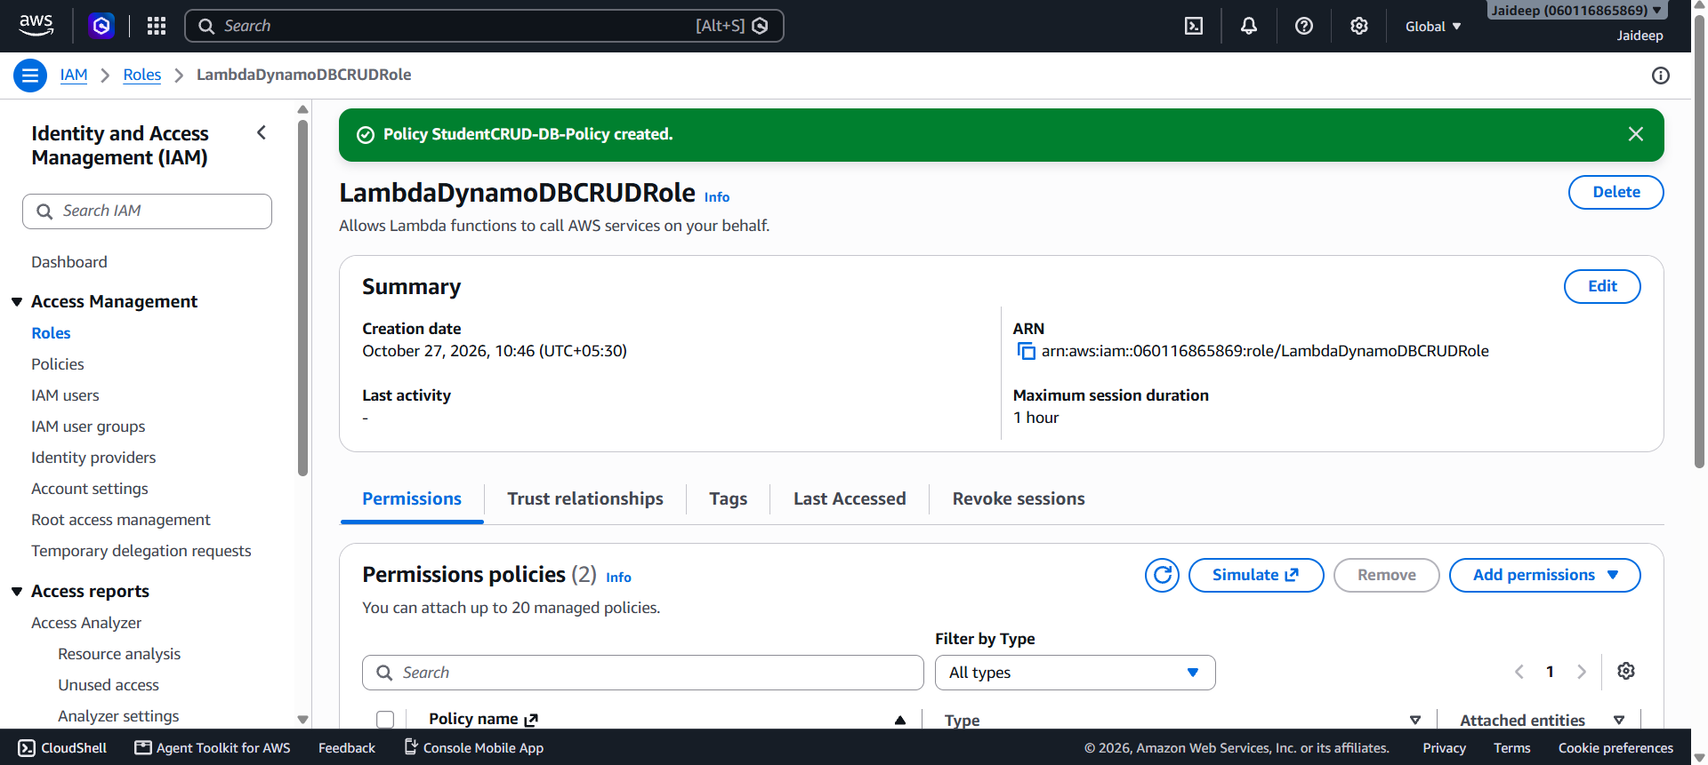
This role allows Lambda to perform the required database operations and write execution logs.
Step 3: Create the Lambda function
- Open AWS Lambda → Functions → Create function.

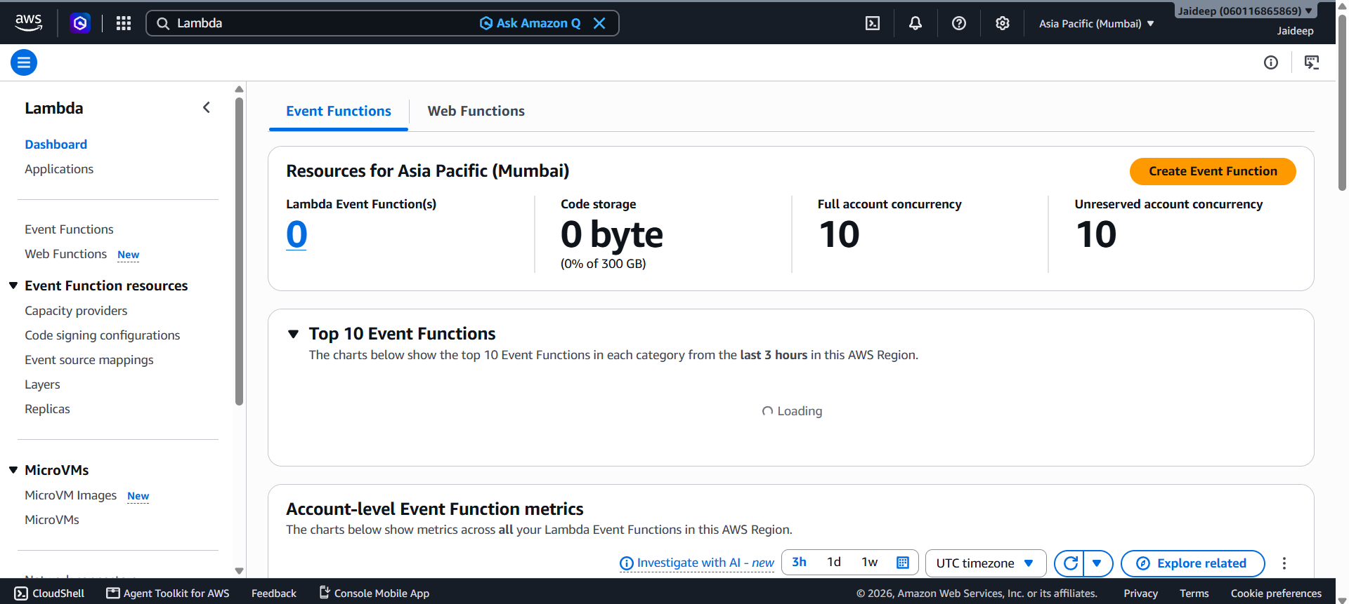
- Select Author from scratch.
- Enter the following details:
  - Function name: StudentCRUDLambda
  - Runtime: Python (a currently supported Python version)

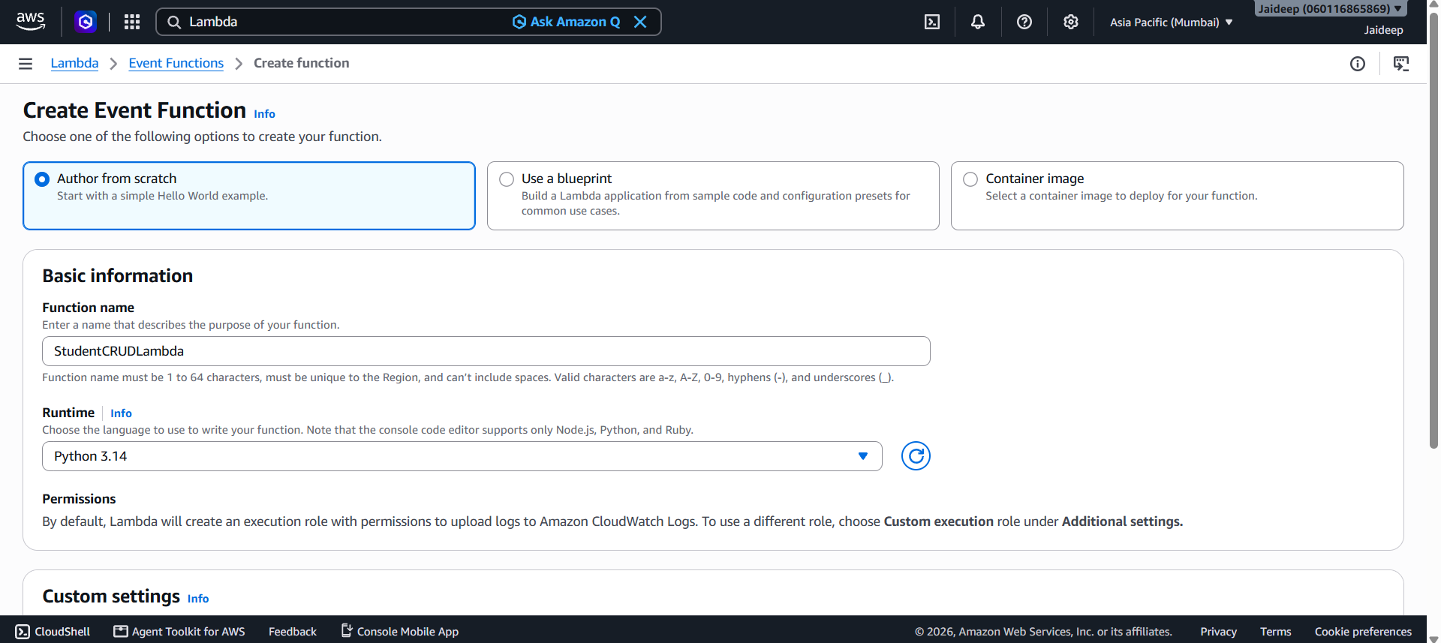
  - Execution role: Use an existing role
  - Existing role: LambdaDynamoDBCRUDRole

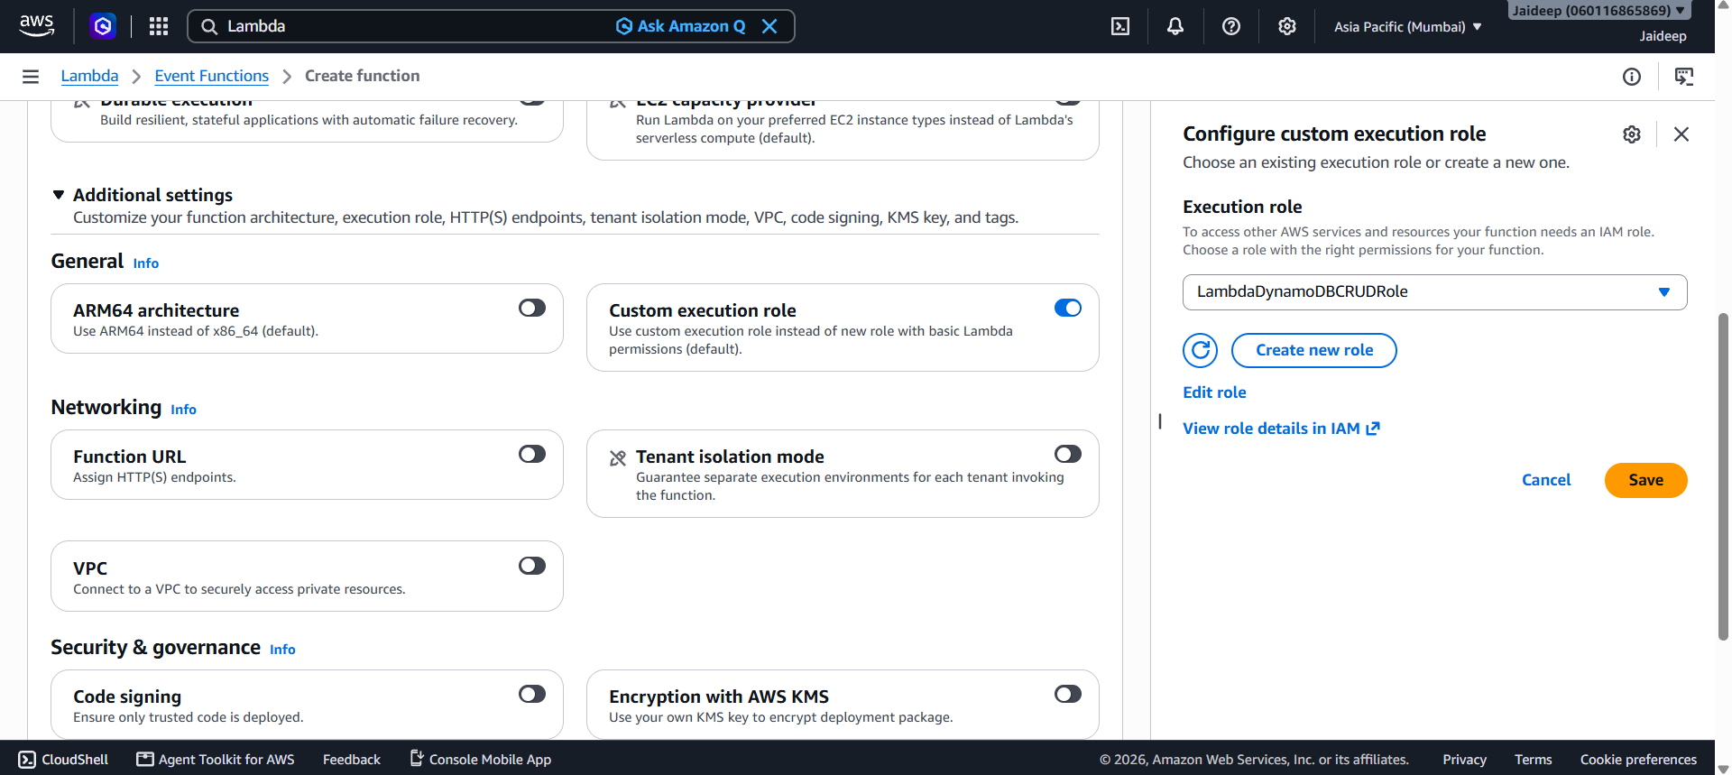
- Ensure the function is created in ap-south-1.
- Click Create function.

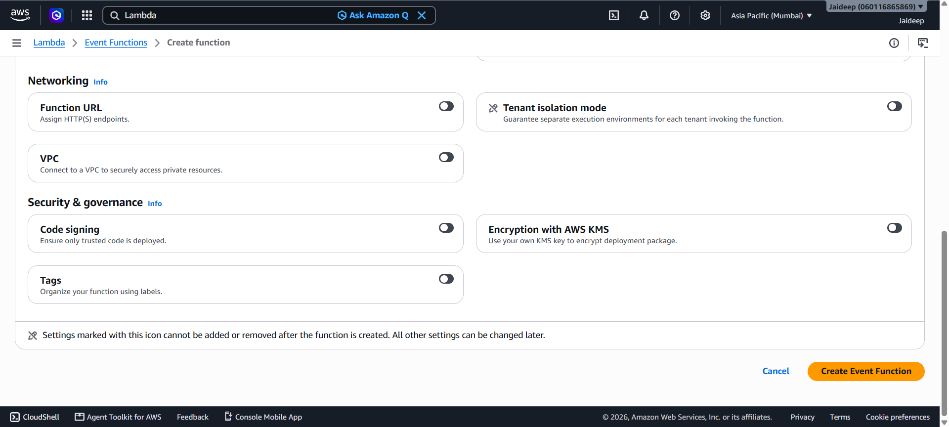

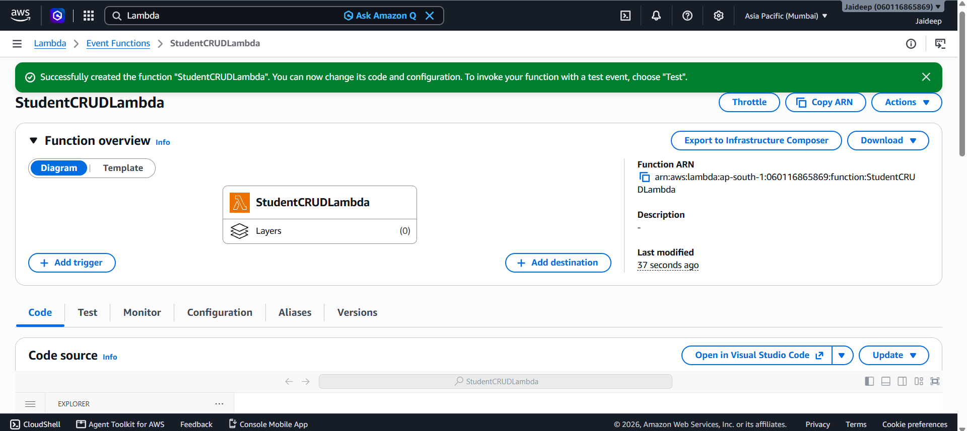
- Open the code editor and replace the contents of lambda_function.py with the following code.
5. Python program
This single Lambda function handles all four CRUD operations by checking the incoming HTTP method and student ID.

import json
import boto3
import os

dynamodb = boto3.resource("dynamodb", region_name="ap-south-1")
table = dynamodb.Table("StudentRecords")

def response(status, data):
return {
"statusCode": status,
"headers": {
"Content-Type": "application/json"
},
"body": json.dumps(data)
}

def lambda_handler(event, context):
try:
method = event.get("requestContext", {}).get(
"http", {}
).get("method", event.get("httpMethod", ""))

params = event.get("pathParameters") or {}
student_id = params.get("studentId")

body = event.get("body")
if isinstance(body, str):
body = json.loads(body) if body else {}
elif not isinstance(body, dict):
body = {}

if method == "POST":
if not body.get("studentId") or not body.get("name") or not body.get("course"):
return response(400, {"message": "studentId, name and course are required"})

table.put_item(
Item={
"studentId": body["studentId"],
"name": body["name"],
"course": body["course"]
},
ConditionExpression="attribute_not_exists(studentId)"
)
return response(201, {
"message": "Student created successfully"
})

elif method == "GET":
if not student_id:
return response(400, {"message": "studentId is required in the URL"})

result = table.get_item(
Key={"studentId": student_id}
)
item = result.get("Item")

if not item:
return response(404, {"message": "Student not found"})

return response(200, item)

elif method == "PUT":
if not student_id:
return response(400, {"message": "studentId is required in the URL"})

if not body.get("name") or not body.get("course"):
return response(400, {"message": "name and course are required"})

result = table.update_item(
Key={"studentId": student_id},
UpdateExpression="SET #n = :name, course = :course",
ConditionExpression="attribute_exists(studentId)",
ExpressionAttributeNames={"#n": "name"},
ExpressionAttributeValues={
":name": body["name"],
":course": body["course"]
},
ReturnValues="ALL_NEW"
)
return response(200, result["Attributes"])

elif method == "DELETE":
if not student_id:
return response(400, {"message": "studentId is required in the URL"})

table.delete_item(
Key={"studentId": student_id},
ConditionExpression="attribute_exists(studentId)"
)
return response(200, {
"message": "Student deleted successfully"
})

return response(405, {"message": "Method not allowed"})

except table.meta.client.exceptions.ConditionalCheckFailedException:
return response(404, {
"message": "Student already exists or does not exist"
})

except Exception:
print("Unexpected error occurred")
return response(500, {
"message": "Internal server error"
})

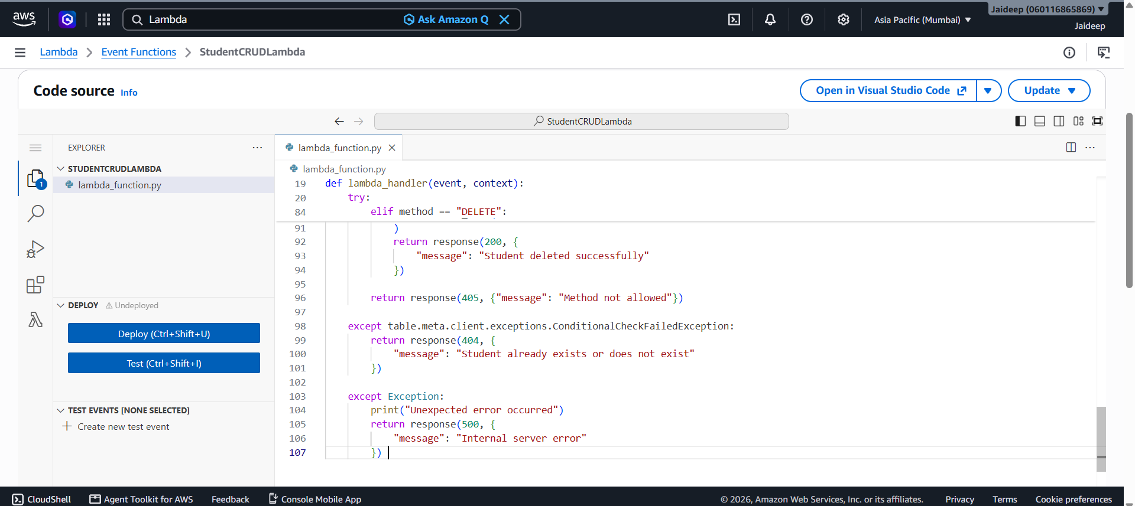
- Click Deploy to save the code.

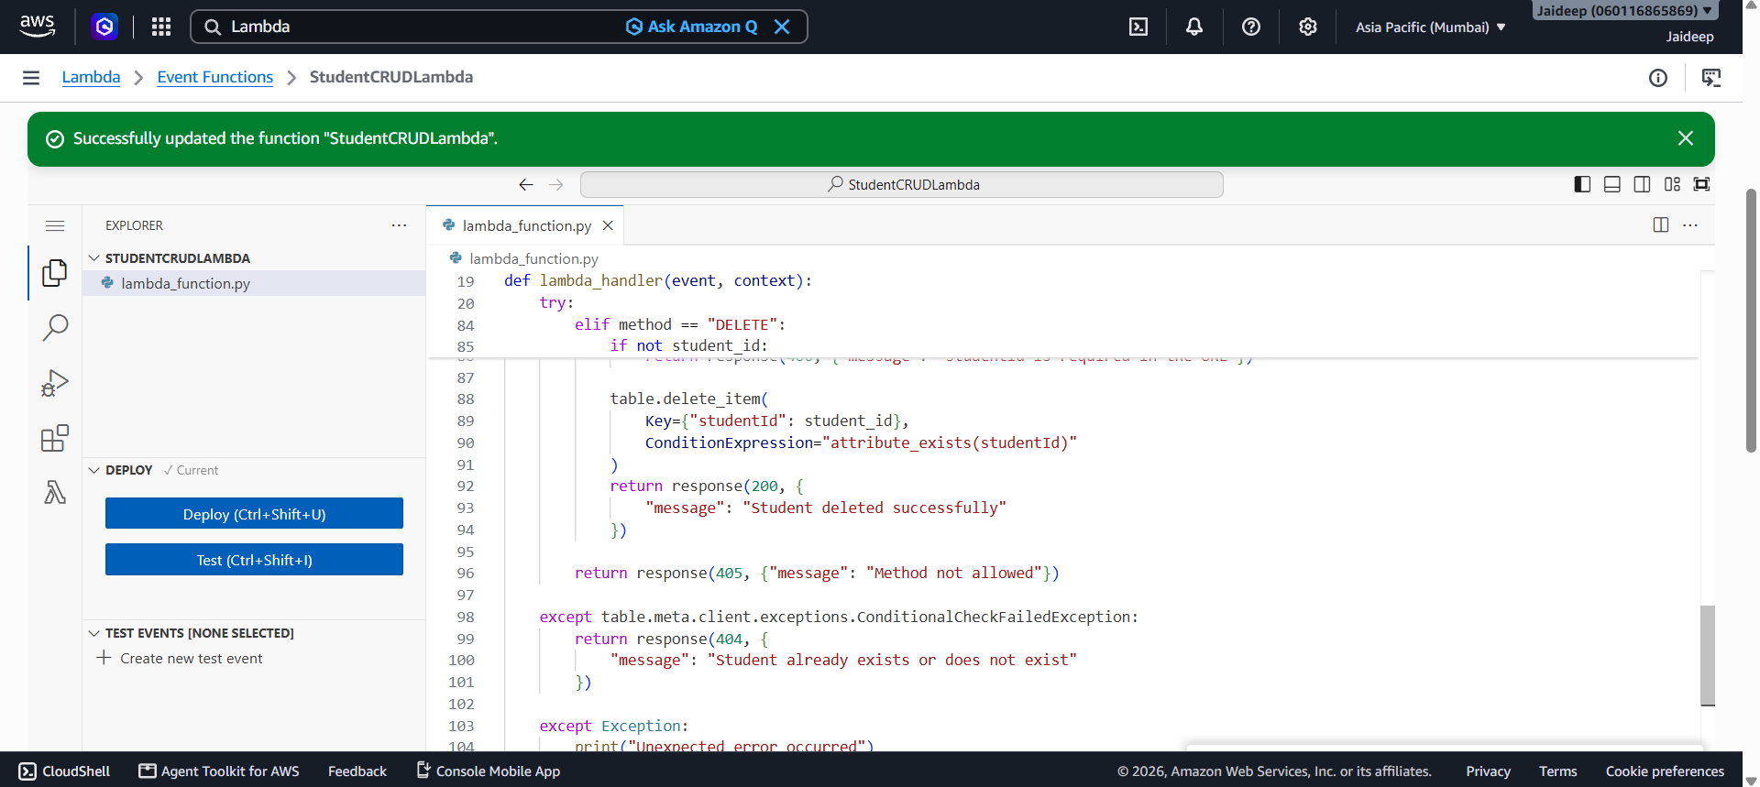
The code uses the DynamoDB put_item, get_item, update_item, and delete_item methods. The API Gateway event provides the HTTP method and, for read, update, and delete, the student ID from the URL.
Step 4: Create an API in Amazon API Gateway
- Open Amazon API Gateway in the AWS Console.

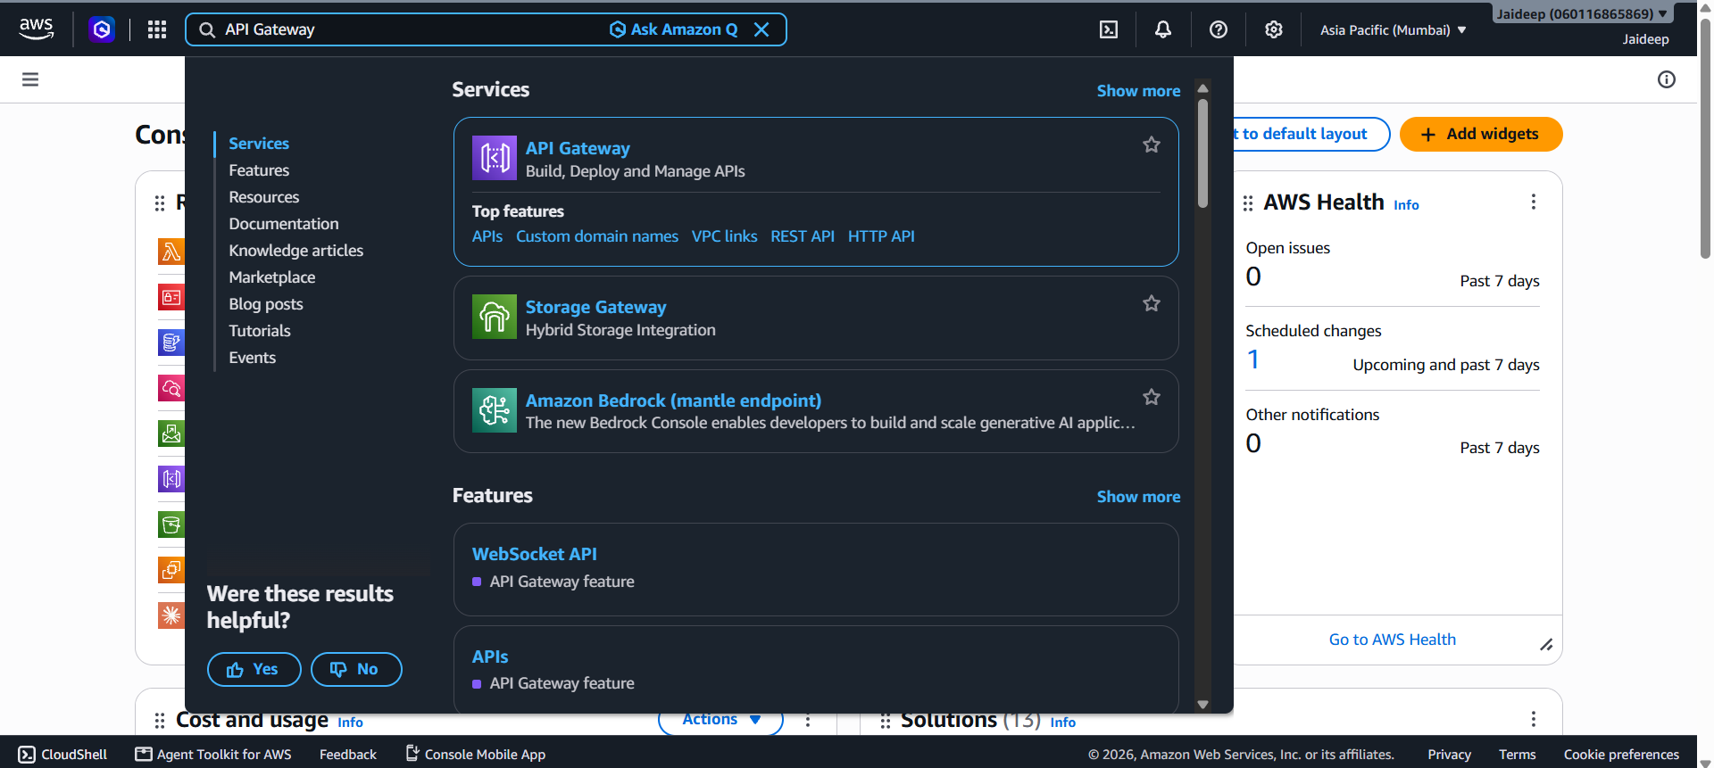
- Select Create API.

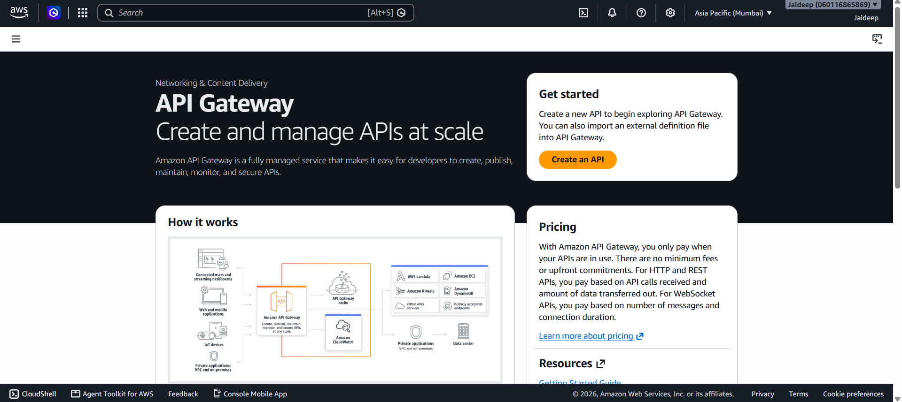
- Choose HTTP API and click Build.

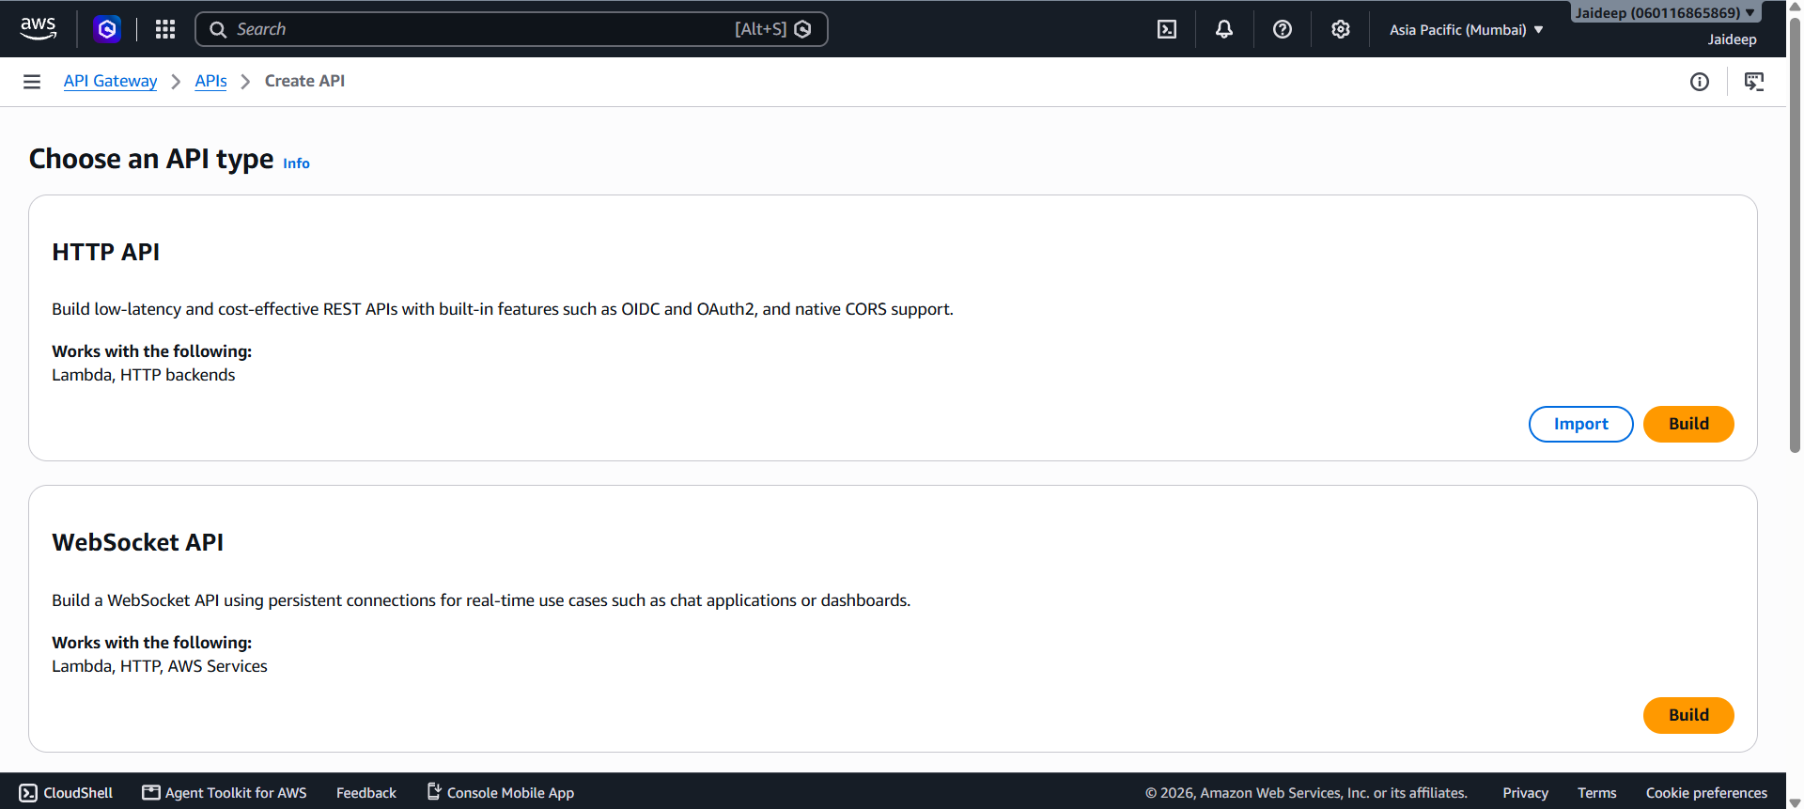
- Enter the API name StudentCRUDAPI.
- Add a Lambda integration:
  - Integration type: Lambda
  - Lambda function: StudentCRUDLambda
  - Region: ap-south-1

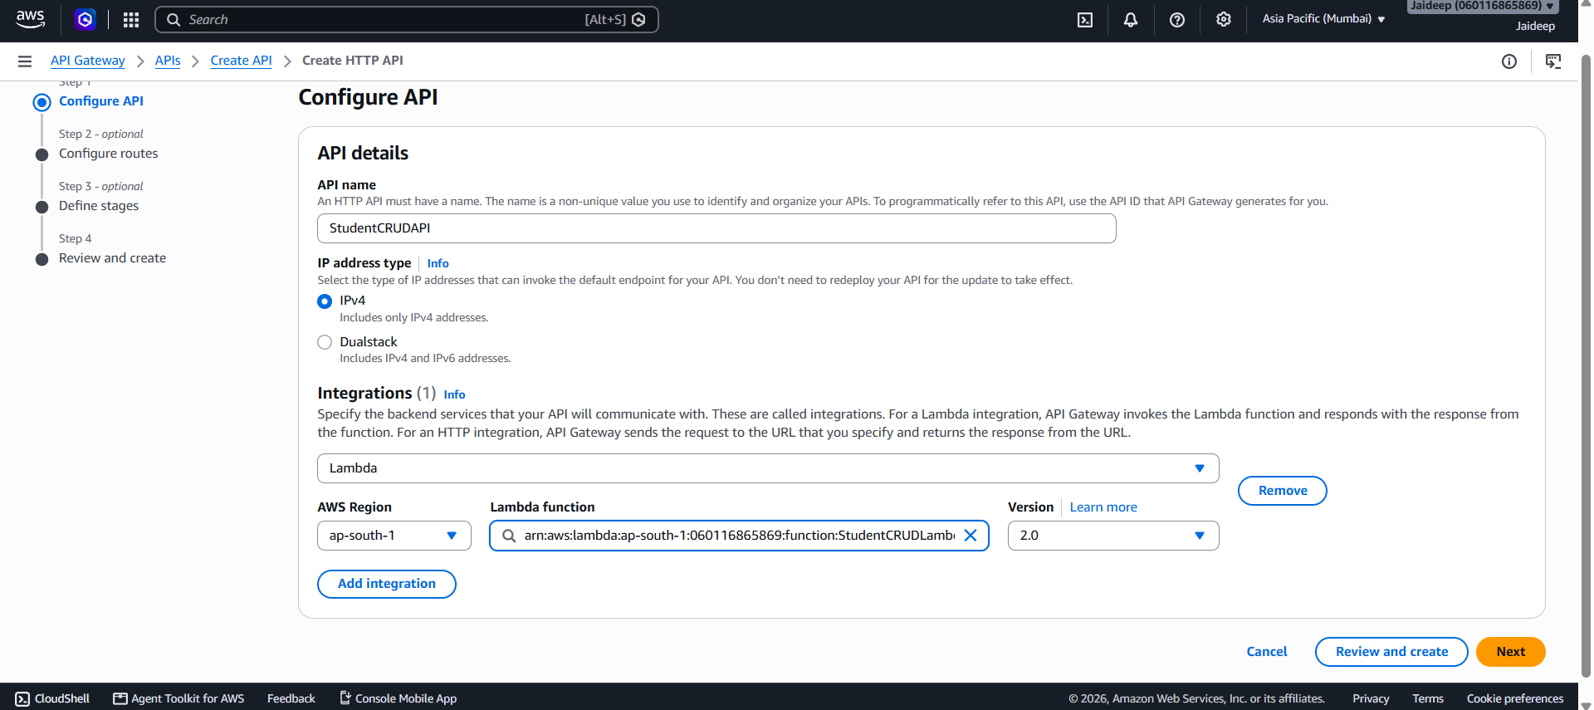
- Create the API and configure the following routes.
HTTP method | Route | Operation
POST | /students | Create a student
GET | /students/{studentId} | Read a student
PUT | /students/{studentId} | Update a student
DELETE | /students/{studentId} | Delete a student
- Attach each route to the StudentCRUDLambda integration.

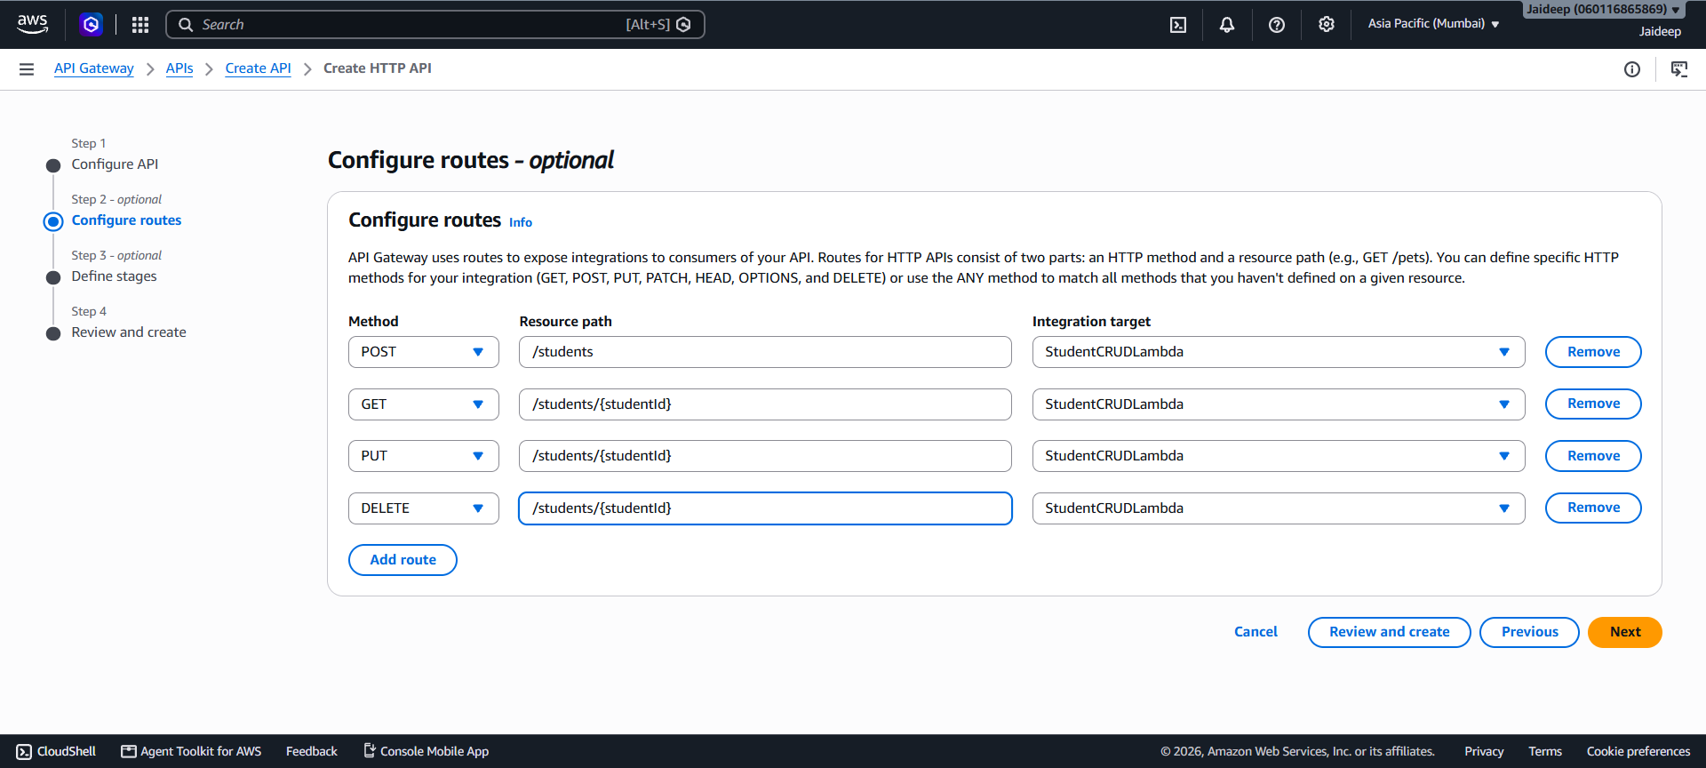
- Configure the API's $default stage for automatic deployment, or deploy the API to a named stage such as test.

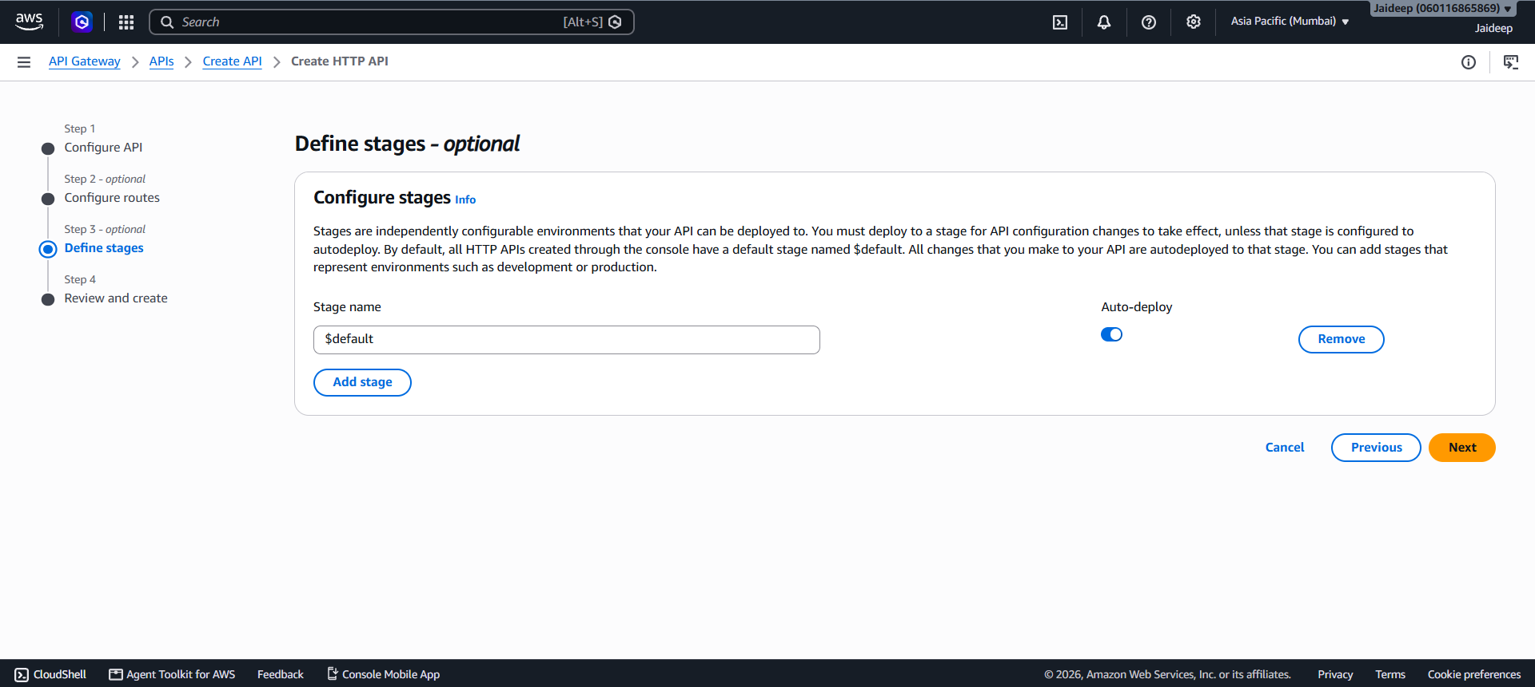

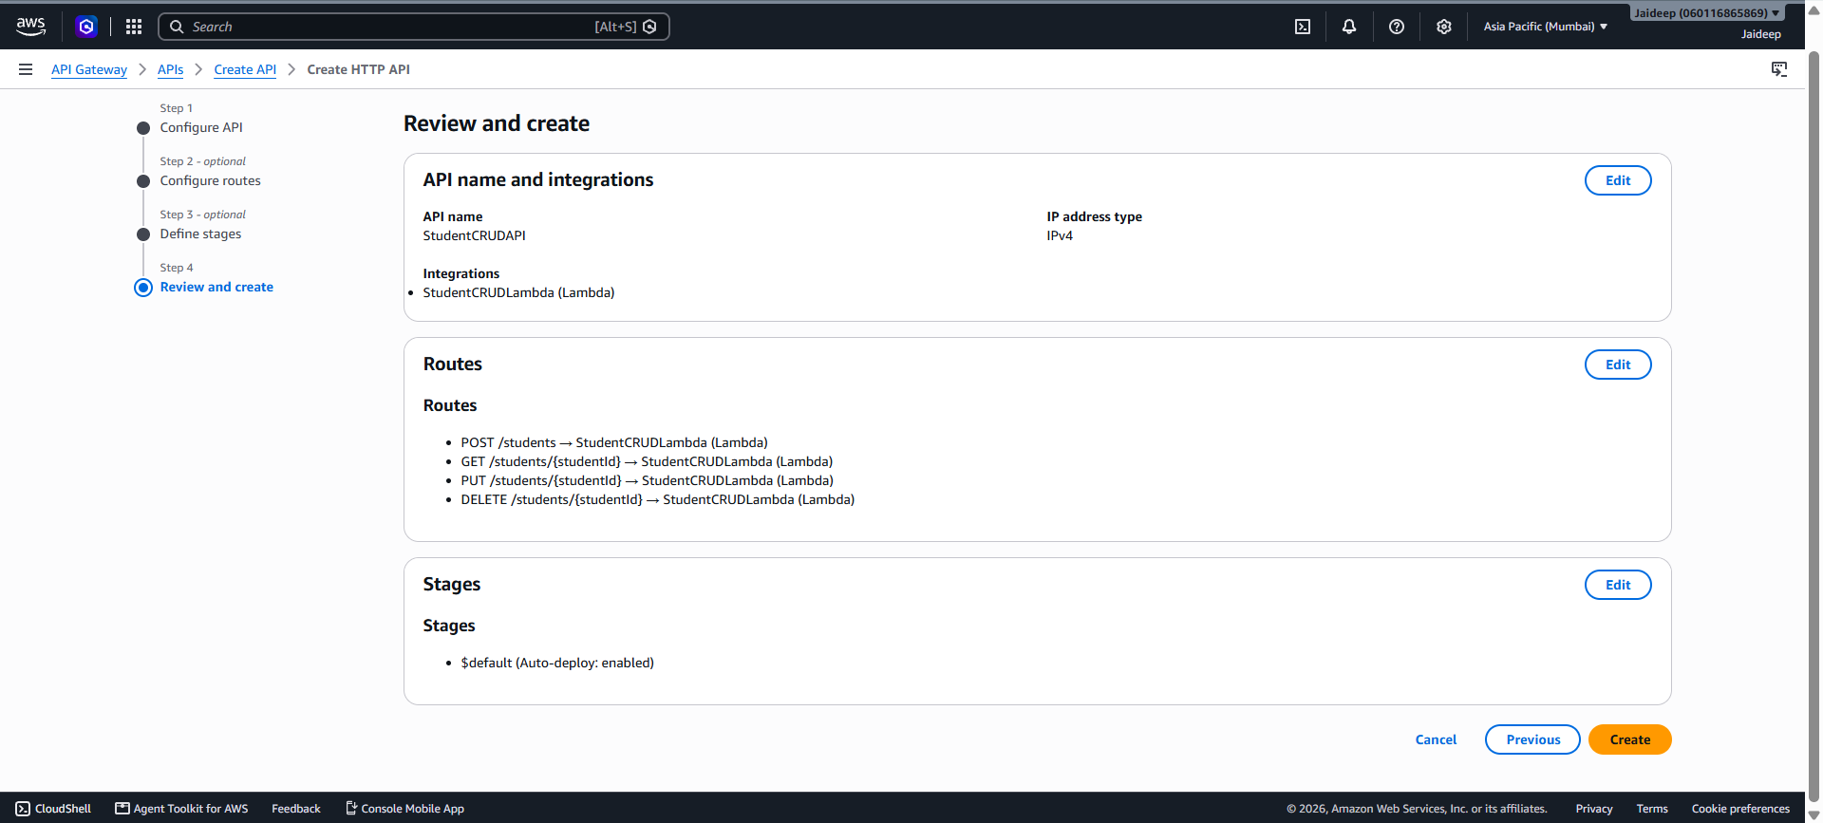

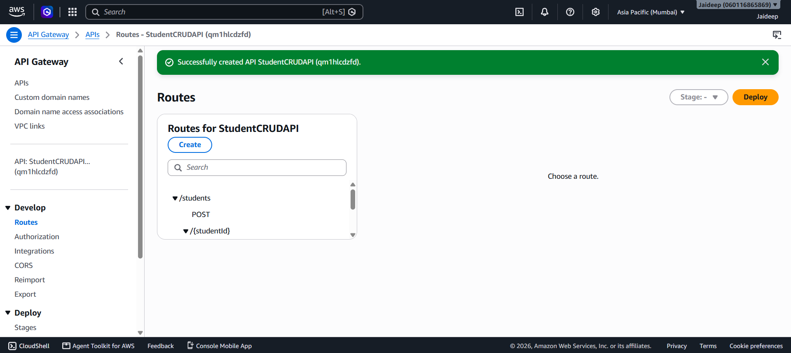

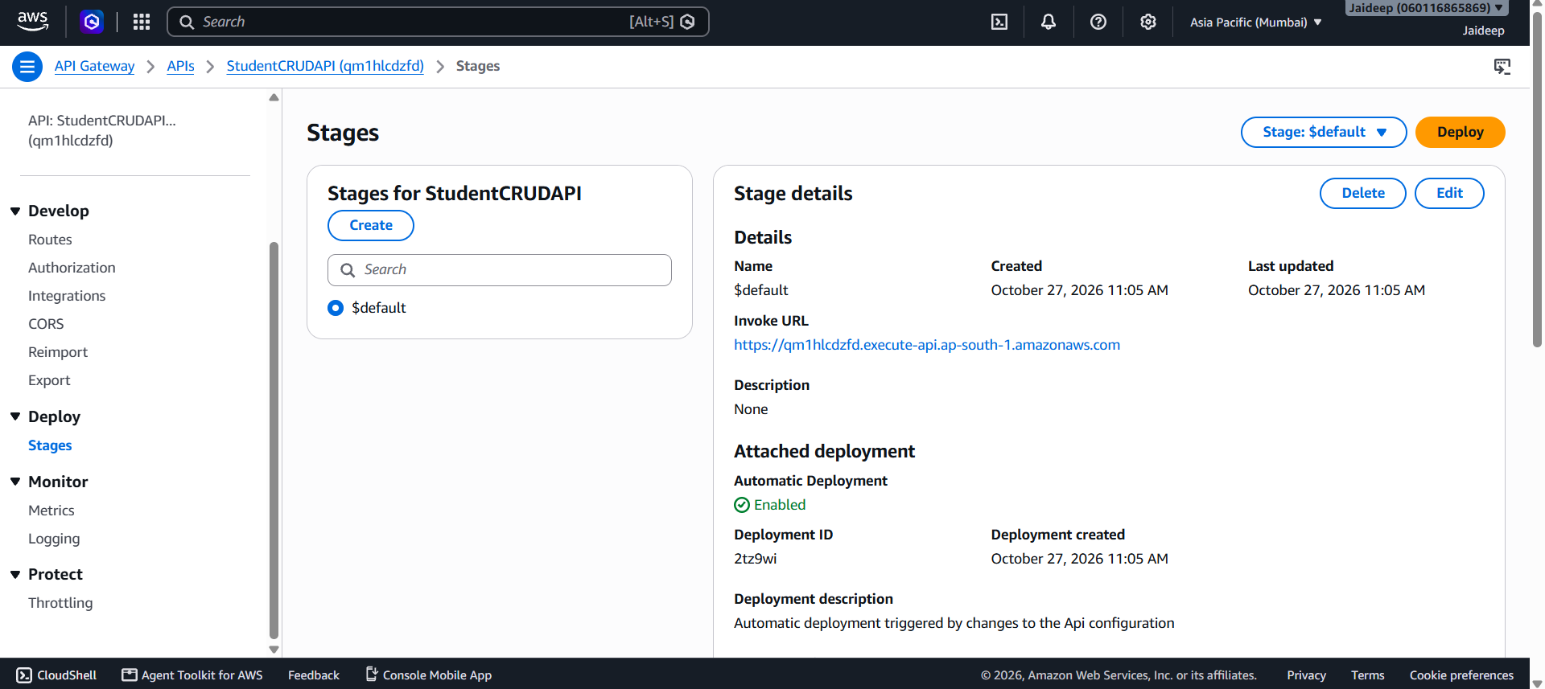
- Copy the Invoke URL shown in the API Gateway console. It will be used to test the API.
API Gateway passes the HTTP request to Lambda, and Lambda returns the result to the client.
6. Testing the CRUD operations
Use an API testing tool or a terminal with curl. Replace YOUR_API_INVOKE_URL with the actual Invoke URL copied from API Gateway. Do not include a trailing slash.
Test 1: Create a student (POST)

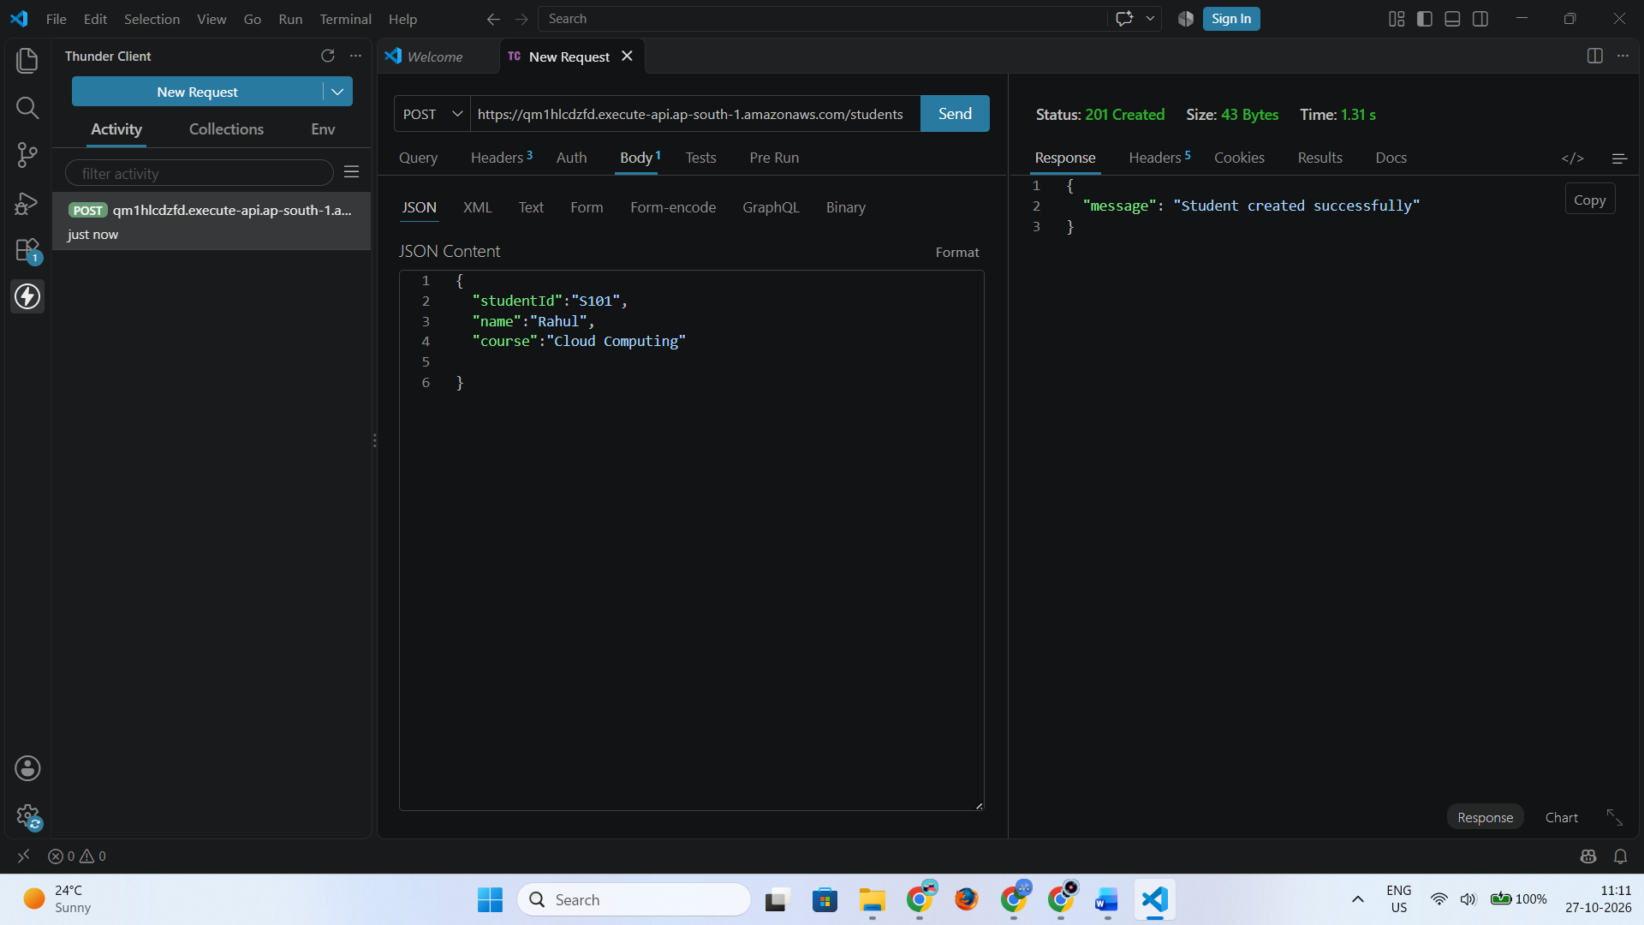Test 2: Read a student (GET)

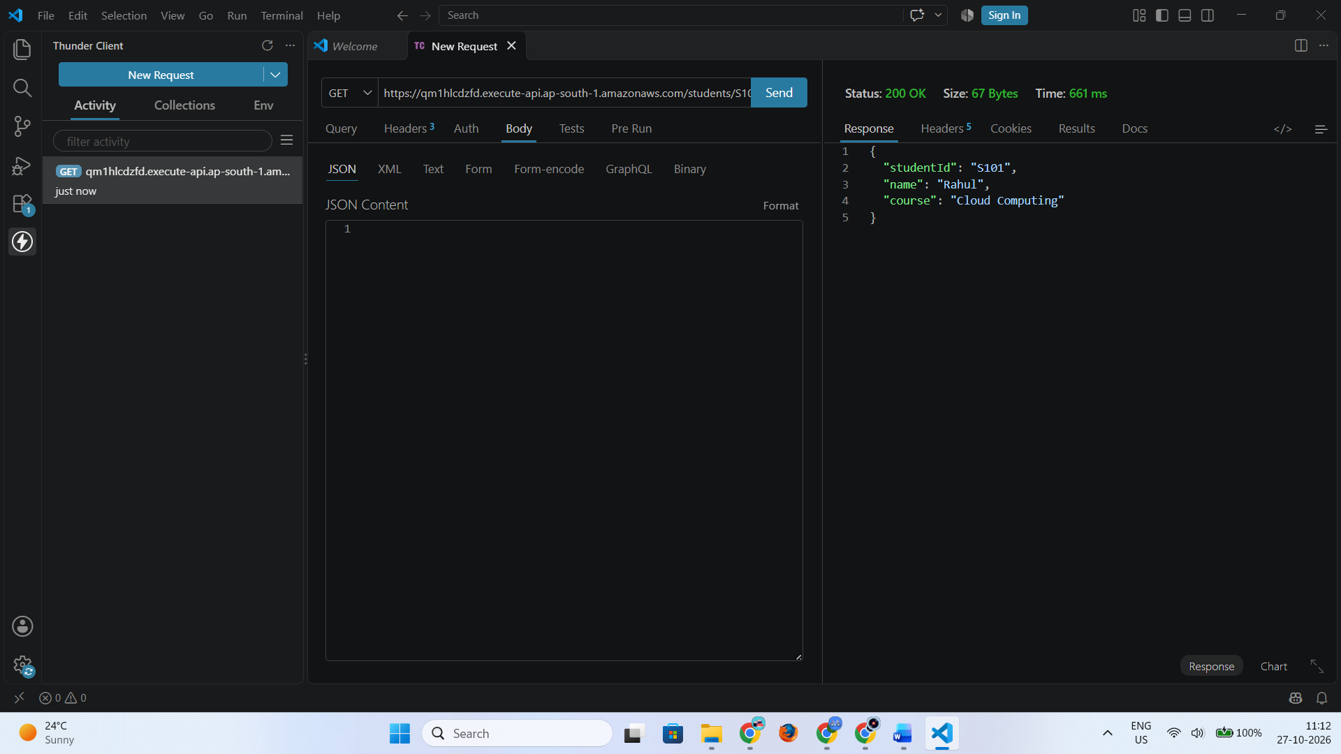Test 3: Update a student (PUT)

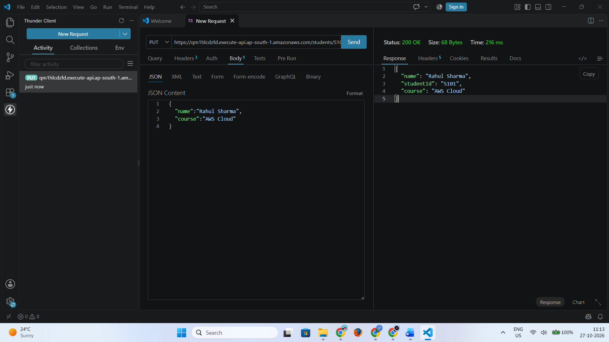Test 4: Delete a student (DELETE)

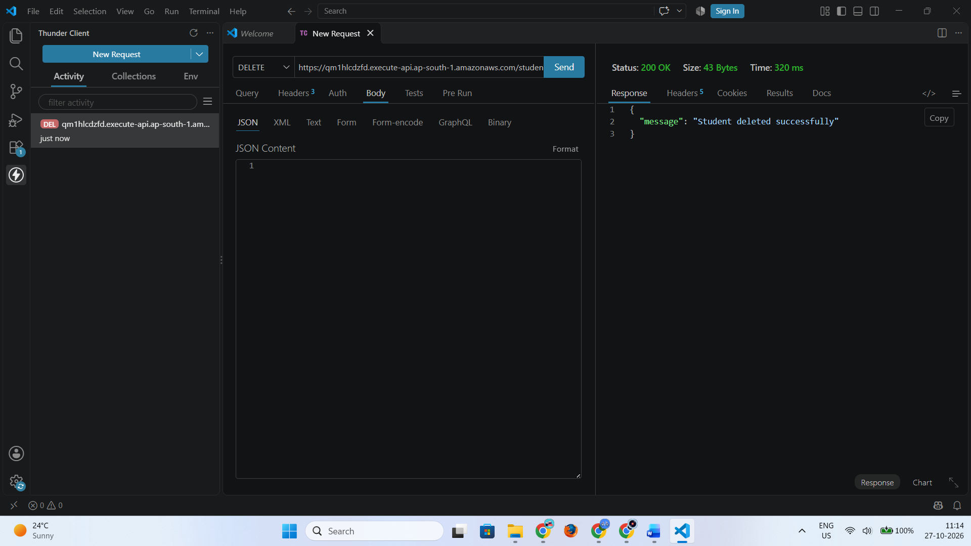After deleting the student, send the GET request again. The API should return 404 Not Found.

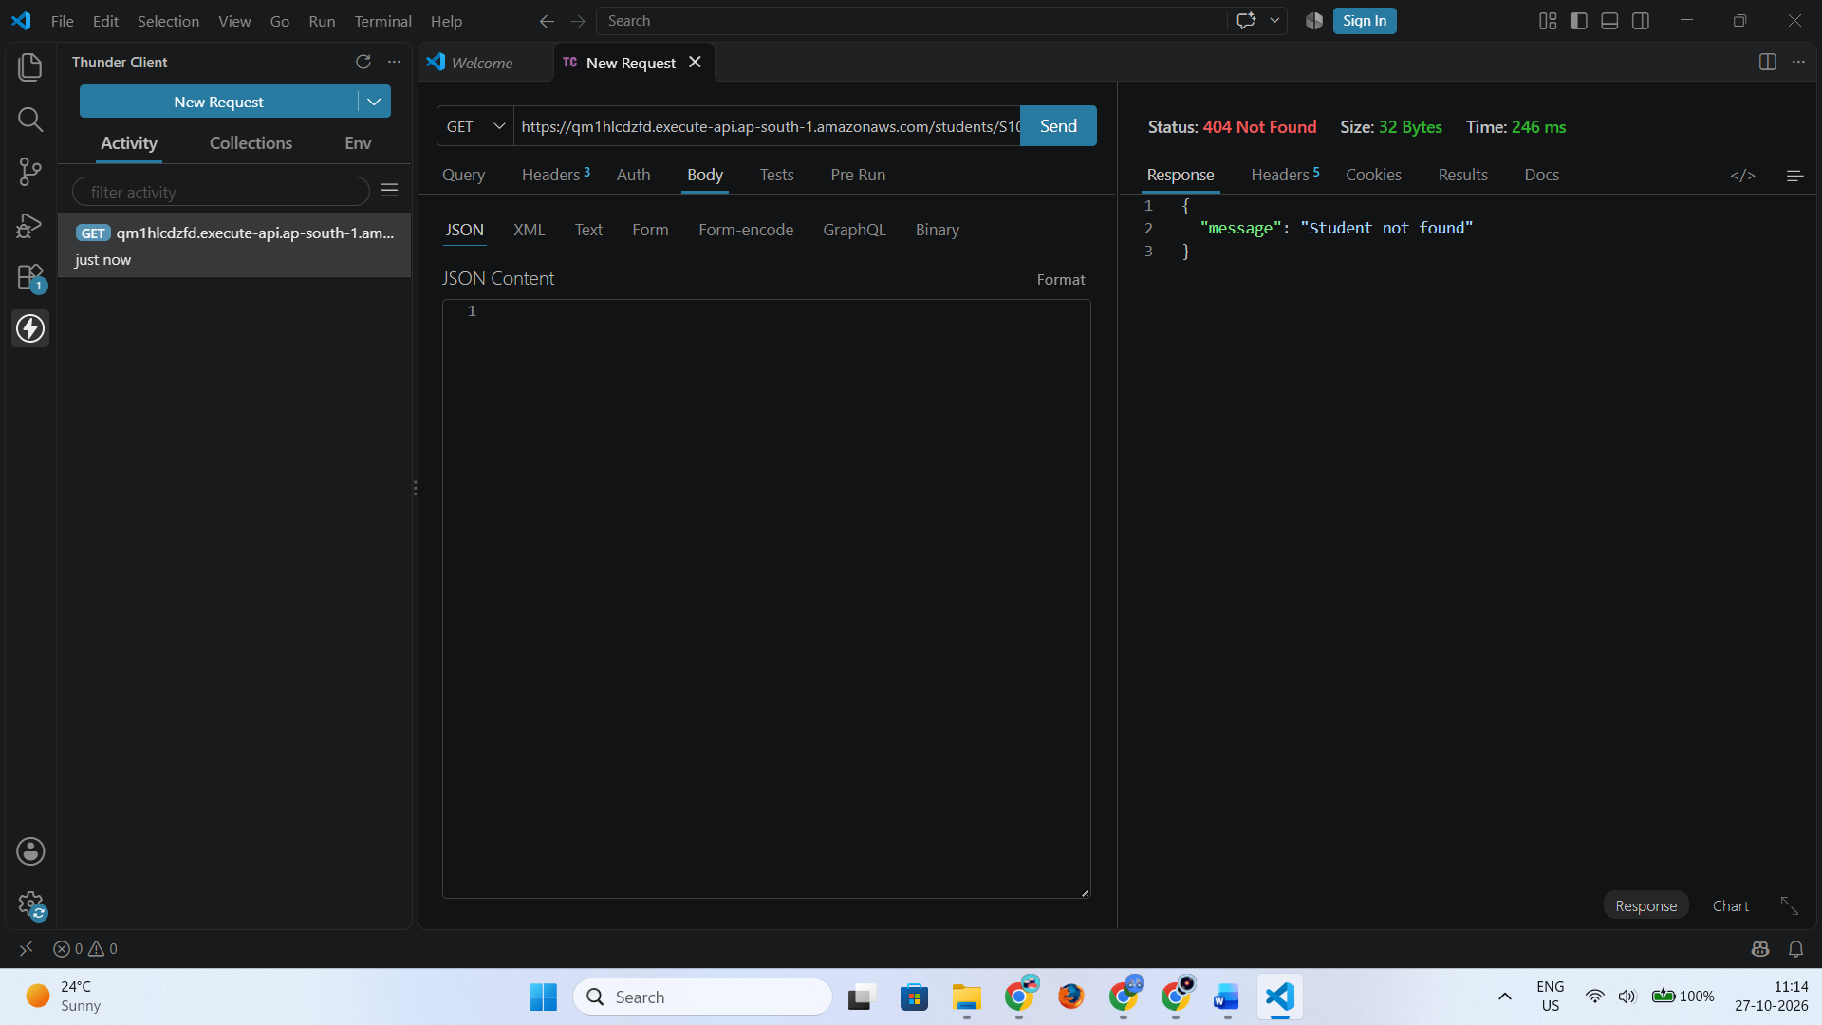
7. Verification
Open Amazon DynamoDB → Tables → StudentRecords → Explore table items to verify the records after each operation.
Test | Expected result
Create student | Record is inserted into the table
Read student | Correct student details are returned
Update student | Name and course are modified
Delete student | Record is removed from the table
Read after deletion | 404 Not Found is returned
8. Result
The integration of AWS Lambda with Amazon DynamoDB using Amazon API Gateway was implemented in the Mumbai region (ap-south-1). The API was configured to perform Create, Read, Update, and Delete (CRUD) operations on student records using HTTP requests.
9. Precautions
- Ensure all AWS resources are created in the same region, ap-south-1.
- Verify the DynamoDB table name and partition key.
- Attach the correct IAM permissions to the Lambda execution role.
- Deploy the Lambda code after making changes.
- Use the correct API Invoke URL and HTTP methods.
- Avoid exposing sensitive information in API responses or logs.
- After completing the practical, delete any test resources that are no longer required to avoid unnecessary charges.

